Aggregating or diversifying risk? Tail correlations, transmission flows and prices between two wind power areas
Johannes Mauritzen, BI Norwegian Business School,+4798251675, Johannes.mauritzen@bi.no

Overview

When wind power was en emerging technology, generation tended to be built out in certain countries and regions that provided financial subsidies, such as Denmark and Northern Germany in Europe and California in the United States. This often meant that wind power's intermittency could be dealt with partially through transmsission to neighboring areas.

Wind power costs have come down dramatically in the previous decade, and on-shore wind power is often competitive with traditional generation in many areas. This has meant that wind power capacity has been built up in many more locales, often in countries or regions adjacent to each other. Given available transmission capacity, such geographic dispersion can act as a form of diversification: mitigating the risks that stem from wind power's intermittency. When there is less wind power in one place, power can be transferred from a neighboring area where the wind is blowing.

However, experience from other asset classes, both real and financial, have shown that risks that appear to be diversified away in normal times, may show strong correlations during extreme events. For example, previous to the large nationwide house price declines from 2006 to 2010 in the US, housing markets were assumed to be determined mainly by local factors and that downturns would be isolated geographically. The related financial crisis of 2008-2009 also showed how diverse financial asset classes that often move in opposite directions could become strongly positively correlated in a crisis: for example stock and investment grade bond prices that both fell during the crisis.

Most analysis of wind power's effects on power prices, price variation, and system stability have focused on average effects. Yet this can lead to misleading inference. Wind power output does not tend to be distributed normally, with few outliers. Instead production tends to closely follow a Weibull probability distribution, which has a fat tail, and where periods of large positive production, far removed from the mean value of the distribution, can be expected to happen relatively frequently.

In this article I study data from Denmark and Sweden: two countries with large wind power penetration and which are connected through both large physical transmission capacity as well as through the common Nordic electricity market. I use hourly data from 2017 and 2018 on wind power production, electricity prices, transmission capacities and flows. I particularly focus on the two southernmost price areas of Sweden, which contain the majority of Swedish wind power capacity and which have direct transmission links to the two price areas that Denmark comprises of.

I study the effects of wind power on prices and transmission at different deciles to see if the marginal effect varies between periods where windpower is close to its median values compared to periods where wind power is at its outer tail.

Methods

Methodologically I use a mixed effects model. I model the effect of wind power in both the local price area as well as adjacent price areas, and allow the marginal effect of wind power to vary by deciles of production. I control for both hourly and monthly seasonality. An important identifying assumption is that wind power is exogenous to prices. This assumption is likely to hold as long as wind power is not substantially curtailed, which is relatively rear on the Nordic market.

Results

I present some preliminary evidence that suggests that for much of the distribution of wind power generation, geographic dispersion of wind power can have a diversifying effect. Correlations between wind power production even in adjacent areas are relatively weak. However, a marked difference appears in the 90 deciles of the wind power production. Periods of very high wind power production in a price areas, are associated with a strong correlation for wind power production in adjacent areas. This suggests that the pattern of power flow, congestion in the network, and marginal price effect may be substantially different in these tail periods.

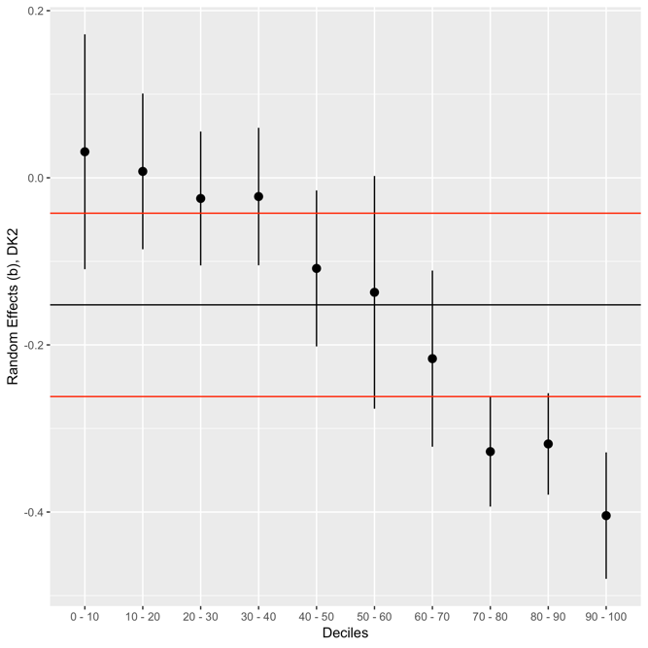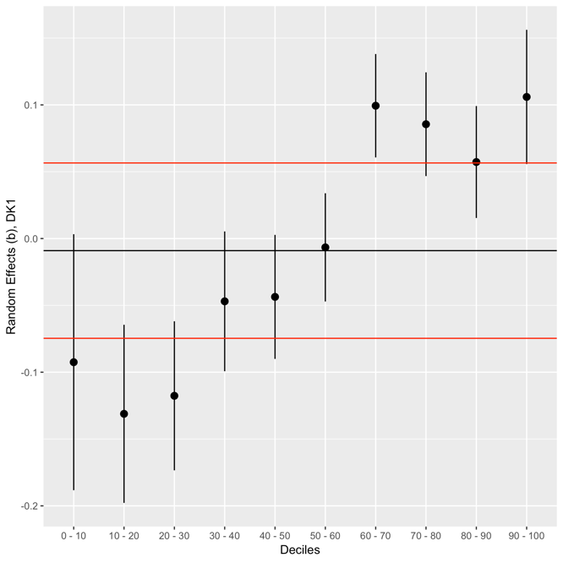

In my main analysis, I find that the average (fixed) effect of wind power production masks substantial variation across deciles. For the DK2 price area (left figure above), the overall average marginal effect has a magnitude that corresponds to a -.15 standard deviation decrease in prices from a 1 standard deviation increase in wind power. However, when the wind power production is in the lower 4 deciles, little to no significant marginal effect is found. For the middle deciles, wind power is found to have a marginal effect close to the average marginal effect (fixed effect) of -.15. However, the top three deciles are estimated at a magnitude substantially higher than that of the average marginal effect. In particular the estimated marginal effect at the top decile is estimated at -.40, nearly three times the average effect.

The marginal effect of wind power in neighboring regions on the DK2 price also displays large variation across deciles of local (DK2) wind power. The marginal effect of wind power in the DK1 area (right figure above) has a average (fixed) effect close to zero, though at low deciles this effect is found to be negative. Counter-intuitively, the marginal effect of wind power on the neighboring area is found to be positive during high deciles.

The explanation for these large variations in marginal price effects of wind production comes from patterns in transmission flows. Periods of high wind power, which tend to be highly correlated across regions, lead to congestion on the transmission net. In turn, this leads to market de-coupling and diverging price effects.

Conclusion

This research shows that analysis that rely on average effects when analysing wind power are incomplete. Wind power correlations across regions increases markedly at high-wind periods, leading to asymmetric effects on prices and transmission. This can have major implications for both valuation of wind farm projects and operation of power markets with high penetration of wind power.

