Overview

The increasing cost of ignoring Coase: inefficient electricity tariffs, welfare loss and distributed energy resources

Niall Farrell, Potsdam Institute for Climate Impact Research, +353 86 1564811, niall.farrell@pik-potsdam.de

I show that British electricity tariffs create substantial welfare loss, equivalent to between six and eighteen percent of domestic consumption value. Losses are greater than unpriced distributional and environmental counter effects. Expected technological change will increase this welfare loss. Deployment of distributed energy resources (e.g. solar) benefits adoptees at the expense of non-adoptees as tariffs are recalibrated to recover fixed costs. Reform on Coasian principles avoids these welfare losses and re-distributional effects. In providing these estimates, I combine household-level micro-data with information on utility cost and tariff structure to simulate the welfare effects of tariff reform and technological change.

Methods

I first provide some theoretical insight into how tariff structure affects consumer welfare, and how this is likely to change with DER deployment. The empirical section proceeds as follows. This paper employs a simulation-based estimation procedure, expanding on the methods of (Borenstein, 2012). Household-level micro-data provide a representative sample of electricity expenditures, income and other socio-economic data. This provides the foundation with which a counter factual Coasian tariff may be simulated. The welfare effects of reform are then estimated in total, on average and by income group. The second stage of analysis concerns DER deployment. Adoption is simulated amongst a subset of households. Utility revenues are calculated relative to costs and recalibrated to ensure full cost recovery, if required. This is carried out for both current British tariffs and the Coasian counterfactual. The welfare effects of this process are then calculated in total and on average amongst adoptees and non-adoptees.

Results

I show that a Coasian volumetric tariff is less than half the current average volumetric tariff, while the standing charge must increase by up to five times to ensure a revenue-neutral reform. I present Coasian tariffs calculated for each of the 11 UK Governmental office regions in Great Britain for both 2015 and 2016.
Current British electricity tariffs create substantial welfare losses, experienced across all income groups (see Table 1). Uninternalized environmental and social externalities do not justify currently inefficient tariffs. Distributional effects are shown to be of concern but are more efficiently addressed via tax-benefit policy. Welfare losses are many times greater than the cost of potentially under-priced environmental externalities.

Coasian pricing brings simplicity to the welfare effects of DER deployment and avoids negative counter-effects. First of all, adoption only occurs under circumstances that are welfare-improving. Second, there are no negative distributional impacts; adoptees benefit only and in proportion to DER electricity consumed and the price differential. There are no knock-on effects for grid-sourced electricity, removing worries of a `utility death spiral'. Figure 1 charts the change in aggregate welfare as a function of electricity displaced and price differential, assuming 2.5 million British households adopt. Deployment is welfare-enhancing in all circumstances, growing predictably with the relative cost reduction and the quantity of displaced electricity. Under a 2.5 million adoptee scenario, Figure 1 shows that households benefit by up to \pounds 55/annum under the most optimistic cost and displacement scenarios. Non-adoptees are unaffected.
When Coasian pricing is not in place, it is cost-effective to adopt once the DER price reaches parity with the retail price. In Great Britain, this is approximately twice marginal cost. DER deployment creates welfare loss in many circumstances and a redistribution of income from non-adoptees to adoptees.

Table 1: Average welfare change by income quintile
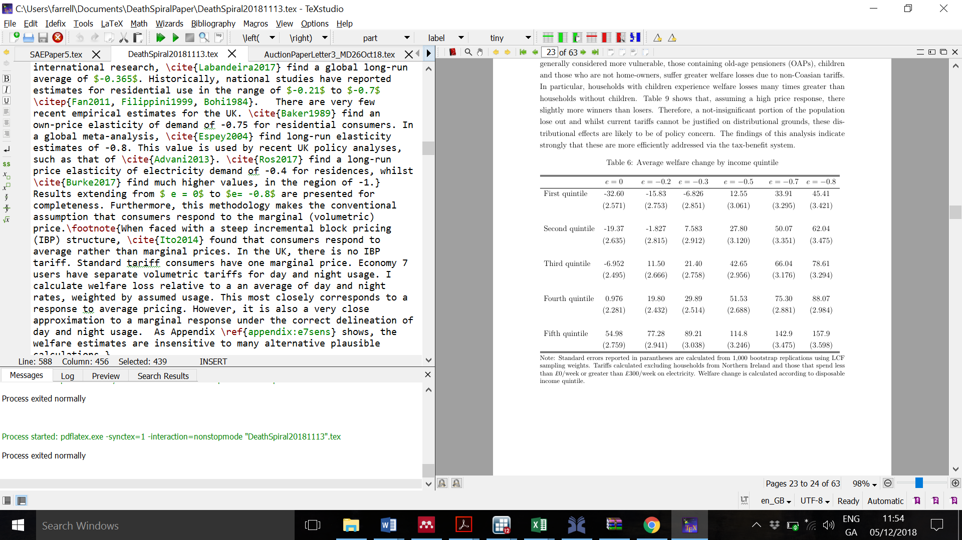
Figure 1: DER adoption and adoptee/non-adoptee welfare change with no Coasian price
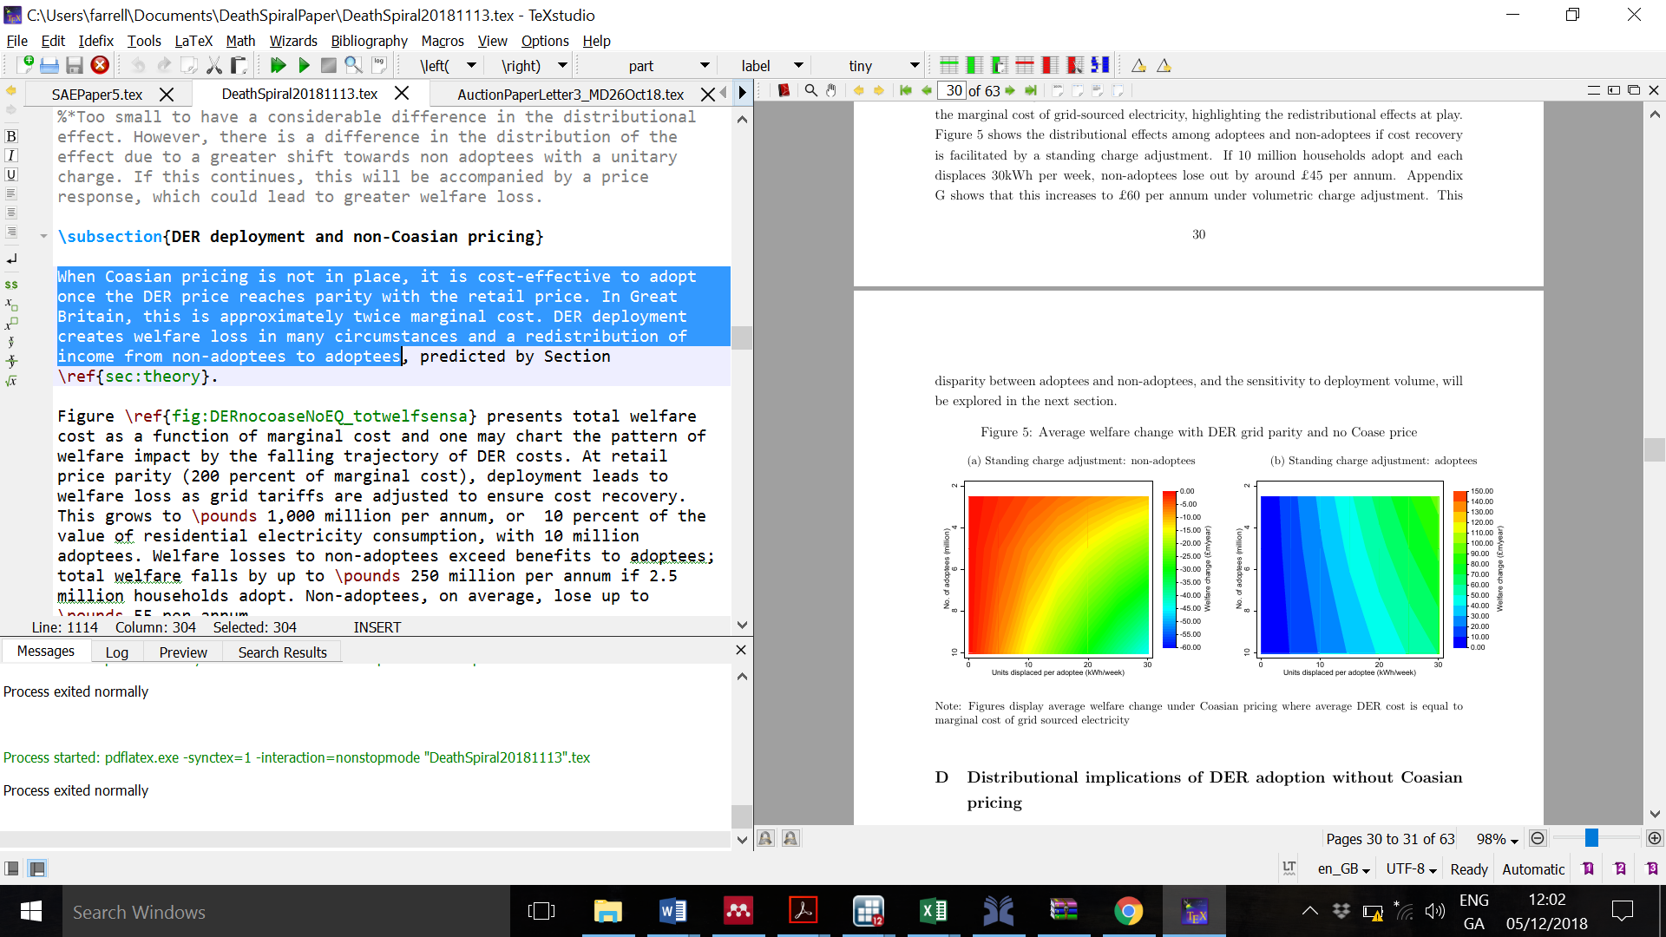

Conclusions

This paper has examined welfare losses associated with British electricity tariffs. Welfare losses are between £729 to £2,234m per annum (6-18 percent of domestic consumption value), or £28 to £86 per household. While the current carbon price floor may be lower than that recommended for a sustainable de-carbonization trajectory, this welfare loss is greater than the implicit cost of avoided emissions.

Distributed Energy Resource (DER; e.g. solar) deployment increases welfare losses and these may be avoided with Coasian tariff reform. As DER prices fall, they will first reach parity with retail prices, inducing adoption. While adoptees benefit, non-adoptees will lose out due to necessary tariff recalibration. These losses will grow with deployment until marginal cost parity. These costs are not insignificant; at retail price parity, a small adoption profile of 2.5 million households leads to an expected welfare loss of \pounds 250 million per annum.

References
Borenstein, Severin. 2012. "The Redistributional Impact of Nonlinear Electricity Pricing." American Economic Journal: Economic Policy, 4 (3): 56-90.

