Overview

Techno-economic grid impacts of widespread net-zero energy building adoption
Sven Scholtysik, Institute for Integrated Energy Systems, University of Victoria, 250-721-6288, sscholtysik@uvic.ca
Cameron Wade, Institute for Integrated Energy Systems, University of Victoria, cameronwade@uvic.ca
Dr. Sean Collins, Institute for Integrated Energy Systems, University of Victoria, seancollins@uvic.ca
Dr. Bryson Robertson, Oregon State University, bryson.robertson@oregonstate.edu
Dr Peter Wild, Institute for Integrated Energy Systems, University of Victoria, pwild@uvic.ca
Dr. Andrew Rowe, Institute for Integrated Energy Systems, University of Victoria, arowe@uvic.ca
Widespread adoption of net-zero energy buildings (NZEB) is frequently identified as a key pathway to the reduction of anthropogenic GHG emissions. Consumer motivation to invest in NZEBs is an observable trend among the urban population, but the implications of widespread NZEB adoption on the electrical system remain vaguely defined.
This research aims to quantify the impacts of high NZEB adoption rates on a hydropower dominated energy system in terms of the province’s GHG emissions and electricity generation mix from 2018 to 2060, while taking population growth induced electricity demand increases, demand profile changes, building turnover rates, and climate change induced hydrological flow changes into account.
Previous work has quantified the long term impacts of NZEB adoption on power systems, yet fails to analyze the flexibility requirements of a hydropower dominated system on the short-term operational time scale.
We analyze the evolution of the British Columbian electricity generation system through techno-economic optimisation in the technologically explicit linear programming “Open Source Energy Modelling System” (OSeMOSYS) and the unit commitment and economic dispatch model PLEXOS.
Using data from Natural Resources Canada (NRCan), BC Hydro, and the National Energy Board (NEB), realistic housing stock turnover rates and NZEB adoption scenarios are developed and used as input for a long-term OSeMOSYS optimization, with multiple resource cost assumptions. Outcomes of the optimization are then analyzed regarding their operational feasibility in PLEXOS.

Methods
To assess the impacts of widespread adoption of NZEB on the energy system, we create an energy system optimization model (ESOM) in which electricity and heating demand can each be met by a variety of technologies, whereas NZEB demand has to cumulatively be met by solar PV. A technology-explicit bottom-up energy systems representation is optimised to minimize total discounted system cost for a 45-year period, from 2015 to 2060. Electricity and heat generation technologies are defined in terms of costs, operational characteristics, and GHG emissions. Demand, carbon polices, and NZEB penetration are defined exogenously. The results are tested regarding their operational flexibility with the unit commitment and economic dispatch model PLEXOS. The context for this study is the Canadian Province British Columbia, in which the electricity generation mix is dominated by hydro powered electricity generation. The residential electricity and heating demand is based on database of more than 5,100 residential buildings, located throughout British Columbia.
In the ESOM, energy demand is split into space heat demand, electricity demand for non-NZEB, and electricity demand for NZEB. To ensure demand satisfaction, resources are used by technologies to create fuels that satisfy either non-NZEB electricity, NZEB electricity, or space heat demand. Electricity generation options comprise of biomass, wind, commercial scale solar PV, residential rooftop solar PV, geothermal, hydro, combined cycle gas turbines (CCGT), open cycle gas turbines (OCGT), and CCGT with carbon capture and storage (CCS). Space heat demand can be satisfied by resistance heaters, heat pumps, gas furnaces, and wood fired systems.
NZEB demand is the demand of all NZEB present in a year. NZEB demand includes electrified heating demand for NZEBs. The NZEB demand has to be cumulatively satisfied on an annual basis by electricity from residential solar PV generation. However, in times when the NZEB demand is higher than the solar PV generation, electricity from the grid can be used to meet the NZEB demand. In times when the NZEB demand is lower than the solar PV generation, the electricity from solar PV can be used to satisfy the normal electricity and electrified heating demand.
In each time slice, each electricity generating technology can operate in one of three modes per unit of installed capacity. Mode 1 produces electricity that satisfies non-space-heat demand, Mode 2 produces electricity that is then used by resistance heaters and heat pumps to satisfy the space heat demand, Mode 3 produces electricity that is used to satisfy the NZEB demand in times when the demand is higher than the maximum solar PV production. A capacity demand or reserve margin of 14 % of the peak electricity demand is required to ensure system reliability.
The model starts with exogenously defined residual electricity generation capacities and invests in generation technologies when needed to ensure demand satisfaction. New capacity is subject to additional capital cost. All technologies are subject to fixed operation and maintenance (FOM) costs, and variable operation and maintenance (VOM) costs. After reaching the end of technology-specific exogenously defined lifetimes, technologies are retired.
In the model, fuels are assigned available amounts, costs, and carbon intensity. Fuels can be assigned to multiple technologies with technology-specific efficiencies. Carbon pricing mechanisms can be applied as monetary penalties for carbon emissions, which leads to increased costs for high carbon technologies. Thermal generators, biomass and geothermal feature endogenously defined capacity factors, while wind, solar and hydro use exogenously defined capacity factors.
The temporal structure of the model is based on 80 time slices per annual model period. Each model period consists of ten representative days. Each day comprises eight time slices. A clustering algorithm chooses representative days from a selection of historical days. The clustering uses hourly electricity demand, space heat demand, hourly potential electricity generation from wind turbines, and hourly potential electricity generation from solar installations. Historical days are assigned one of ten clusters via a k-means clustering algorithm. A single representative day is chosen from each cluster. The probability of selection is the inverse to the “distance” of the day to the cluster center. Each day is reduced from 24 to 8 time slices. The 8 time slices are selected by minimizing the root-mean-square error for the resulting representative day and the corresponding historical day. The significance of each representative day is weighted according to the number of days represented by the cluster. This clustering approach is similar to that used by Nahmacher et al. and is presented in detail in Wade et al.
The residential demand profile is based on a database of over 5,100 residential buildings, which details the hourly electricity demand, if the building is electrically heated or not, the region, and the type of building. The province is divided into four regions: Vancouver Island (VI), Lower Mainland (LM), Southern Interior (SI), and North (N). The building stock is divided into five housing types: single detached houses, row houses, low rise apartments, high rise apartments, and mobile homes. The hourly demand data covers the time period from November 1, 2015 to October 31, 2017. It is scaled to the provincial level according to the population distribution in the four regions.
The following scenarios are analysed: NZEB penetration of 0%, 20%, 40%, 60%, 80%, 100% of all residential buildings, electrified heating demand of 15 kWh/m2, 25 kWh/m2, and 35 kWh/m2.
The ESOM results are then analysed regarding their operational feasibailty for individual years on an hourly basis with the unit commitment and economic dispatch model PLEXOS

Preliminary results
The results presented in this abstract are preliminary and not complete due to time constraints. Figure 1 shows the minimum PV size requirements by region. Figure 2 shows the minimum PV size requirements by building type. Both figures consider the electricity grid as a battery and represent 100% NZEB penetration with a heating demand of 25kWh/m2. It is confirmed that the minimum requirements are largest for the N and LM regions.

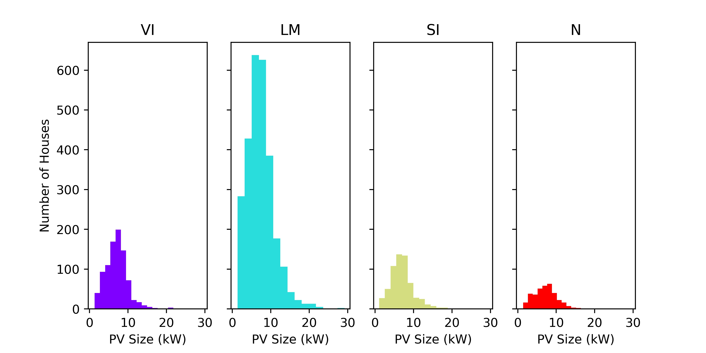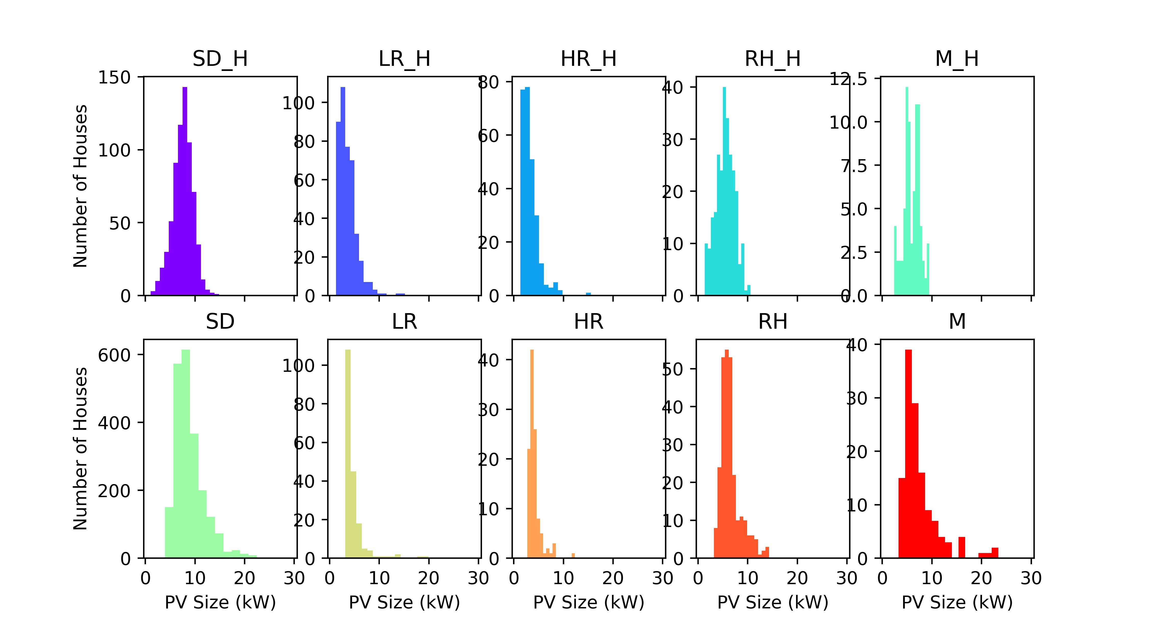
Fig. 1 – PV sizing by region Fig 2 – PV sizing by building type

Conclusions
This research will illustrate that widespread adoption of NZEB can increase the amount of decentralized electricity production in a hydropower dominated system, while reducing the GHG emissions. Flexibility in the hydropower system decreases during times of increased production constraints, like the snowmelt-caused hydro reservoir peak inflow period (freshet). This can lead to significant amounts of curtailed electricity as well as transmission line and storage investments. Our method can be applied to other jurisdictions and produces results that offer valuable insights for policy makers, utilities and system operators. It is expected that scenario based model runs with updated assumptions will provide valuable results in time for the IAEE 2019.

