[Effects of the shale boom on ethylene and propylene prices]

[Soohyeon Kim, College of Engineering, Seoul National University, 82-2-880-8284, kimssoo@snu.ac.kr]

Overview
The rise of shale resources in the United States is changing the global energy and petrochemical industries. The shale boom has not only seen exploration and production (E&P) companies in the United States extract more resources but has also allowed petrochemical manufacturers to utilize abundant and cheap hydrocarbons. Having already impacted the electricity, heating and transportation sectors, this boom is now arriving at the petrochemical sector with the advent of new sources of natural gas liquids (NGLs) and hydro liquid gases (HGLs), which serve as feedstocks used to yield petrochemical products.
Despite such a momentous change, economic investigation in academia is not keeping pace with the expanding impact of shale gas boom, with discussions so far confined within the engineering field, due to the lack of publicly available data and the complexity of supply chains in econometric modeling.
Therefore, to measure the economic effects of shale gas price and identify the determinants of ethylene and propylene prices, this study analyzes price transmission in supply structures. Flow diagrams of the targeted petrochemical markets are configured, contributions of pricing factors are estimated, and the significance of shale gas in the United States is compared with that in Japan, the largest petrochemical producer in Asia. The analyzed period is from 2009 to 2018, and monthly data are used for analysis.

Methods
Our econometric framework is based on the path analysis with mediation and is estimated through structural equation modeling. Modeled supply chains begin with natural gas and crude oil (raw materials), encompass ethane, propane, and naphtha (feedstocks), and end in the production of ethylene and propylene (light olefins). The exogenous independent variables are the prices of natural gas and crude oil, and the final dependent variables are the prices of ethylene and propylene. The intermediate variables between the prices of raw materials and products are the prices and stocks of feedstocks, such as ethane, propane, and naphtha, and quantities in the ethylene and propylene markets. The existence of covariance between the exogenous variables and the variances of all endogenous variables are assumed in estimating structural equations.

Results
The results suggest the following key findings. First, the abundance of cheap ethane in the US, which caused US steam crackers to shift toward the adoption of ethane feedstock, is found to have exerted a divergent impact on the ethylene and propylene markets; the downward trend in ethane prices has reduced ethylene prices but raised propylene prices. Ethylene prices seem to have been decreased more as a result of the expanded production capacities than the low input cost of ethane. This is probably due to a time lag: the decision to invest in production capacities is made when ethane price is optimally low; however, the actual increase in production manifests several years later. Therefore, in statistical analysis, contemporaneous market conditions appear to contribute more significantly to the ethylene price. The price of propylene, by contrast, was confirmed to have increased due to the growing use of ethane feedstock, which yields less propylene than heavier olefins do: the propylene yield from ethane is only 3% (on a unit basis), but that from naphtha and propane are 16 and 17% respectively. Accordingly, the transition to ethane increases the scarcity of propylene supplies and exerts upward pressure on its price.
Second, among the feedstocks replaced by ethane, propane still serves as a determinant of propylene price, while naphtha has lost predictive power for both ethylene and propylene prices. For propane, since the reduced rate of production has been offset by expanding on-purpose PDH plants, the amount of propylene extracted from propane is expected to rise; thus, its price maintains a determinative role as an input factor in propylene prices. Refineries and petrochemical companies have reduced oil-based production of ethylene and propylene as this has lost price competitiveness with gas-based products. Therefore, in contrast to ethane and propane, naphtha has become uncoupled from ethylene and propylene prices.
Lastly, this study compared the results of the analysis of the US markets with those of Japan, the largest light olefin producer in Asia, and identified the regional differences between the two petrochemical industries. The US produces most of its petrochemicals from natural gas and gas-based feedstocks, whereas Japan relies on crude oil and refined naphtha as it has scarce supplies of oil and gas. This difference, which is attributed to their differing resource endowments, reflects the reality of their distinctive supply structures. It was shown from the models that the imported crude oil price is transmitted to Japanese ethylene and propylene prices via the Japanese naphtha price. The equivalent relationship was shown to be insignificant in results for the US. As a result of this structural difference, the impact of the US shale gas boom on petrochemical prices seems not to have reached all global markets. However, as the ethylene supply in the US and the country’s exports are accelerating with the recent increase in facilities, the global market, including Asia, will not be able to continue to avoid the impact of the shale boom.
Below Fig. 1-2 depicts the results of US ethylene and propylene analysis.

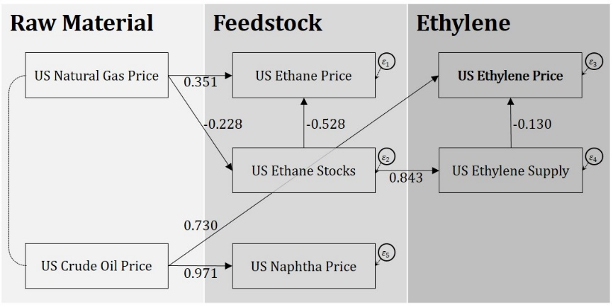
Fig. 1 Result diagram of the US ethylene supply structure

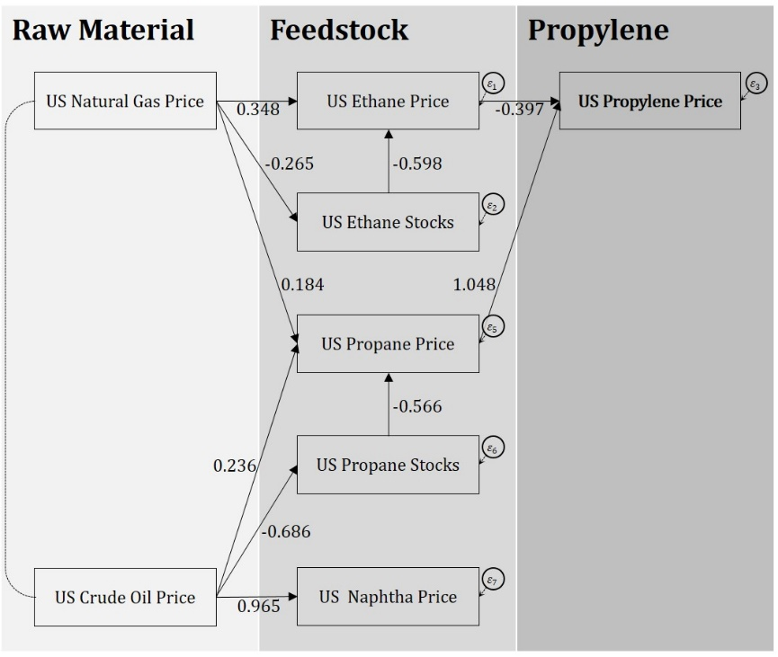
Fig. 2 Result diagram of the US propylene supply structure

Conclusions
This research provides insight into the current and future structural changes driven by the US shale gas boom. As observed, the independence from oil facilitated by the shale gas revolution is spreading beyond the borders of energy and fuel and into the realm of materials and petrochemicals. Natural gas is now encroaching on industries in the US that have relied on oil for the past 150 years. As has been the case for the energy and fuel industries, the petrochemicals industry is anticipated to experience the upheaval not only in the US market but globally. To prepare for the upcoming changes, the discussion should be engendered in every society and debate ignited in various research areas. This study intended to provide an opportunity to provoke consideration from potential stakeholders for these reasons.

