Overview

HEADING TOWARDS a SUSTAINABLE AND democratic ELECTRICITY SYSTEM

Reinhard HAAS, Hans AUER
Energy Economics Group, Vienna University of Technology, E-mail: haas@eeg.tuwien.ac.at
In the history of electricity systems in several countries different boundary conditions existed and exist with respect to price formation in the market. After the periods of state regulation and the first phase of liberalisation of the wholesale markets currently the electricity system faces the third huge challenge: the change towards a bidirectional system, which should be more democratic and sustainable. This process is currently under way in some countries as Germany, Austria, UK and California. And in these countries also a change in the principle how prices come about is already under way. A major reason for this development is that in recent years the electricity generation from variable renewable energy sources especially from wind and photovoltaic (PV) power plants increased considerably.
The three historical periods of market design in electricity markets and the resulting approach of price formation is shown in Fig. 1. A major aspect of the second period (in the middle) in Fig. 1 is, that at the beginning of liberalisation huge excess capacities for electricity generation existed, which made it possible to rely on pure short-term marginal cost electricity pricing.
The major objective of this paper is to analyze and provide insights on how to bring about a sustainable and competitive electricity system with even higher shares of renewable energy sources (RES) and an energy economically balanced system but without escalating political interventions. It is triggered by the current discussion on how to integrate large shares of variable RES but the fundamental intention goes beyond that. It is to show how to head towards real competition in electricity systems, including all dimensions such as generation, storage, but especially the customer side. This is a challenge for all countries world-wide.

Method

Our method of approach is based on the following principles: (i) Crucial is coverage of residual load (= difference between final electricity demand and generation provided by non-flexible electricity generation) ; this is modeled on an hourly base over a calendar year based on assumed variable RES generation and development of the load profile; (ii) Deduction of available conventional and backup capacities including must-run (iii) flexibility on the demand side based on consumer behavior incl. flexibility instrument such as batteries etc.; (iv) hourly electricity prices equal to short-term marginal costs and scarcity rents.

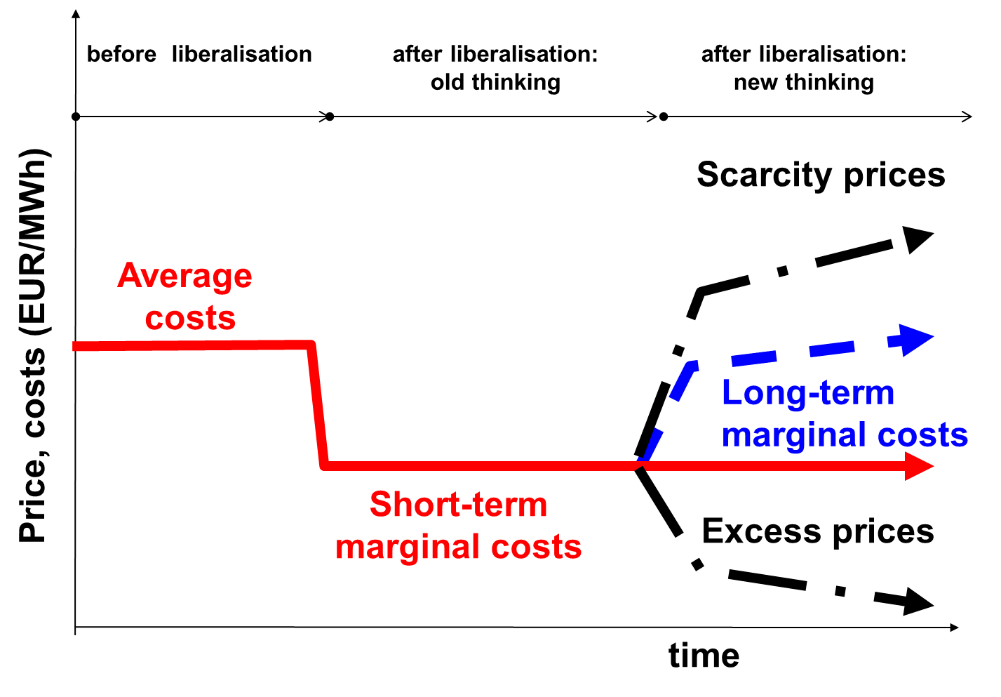 | 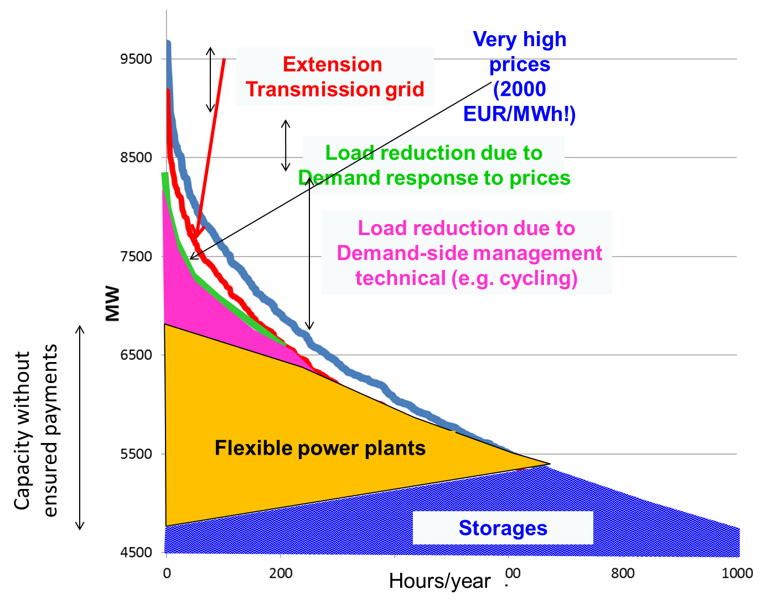
Fig. 1. Three periods of market design in electricity markets and the resulting approach of price formation | Fig. 2. Contributions of various supply-side and demand-side options to meet residual load at times of scarcity

Results
The major results are:
- Of core relevance for a complete markets and to enhance competition is a pricing system in an energy-only market (EOM) where the price signals provide information about scarcity or excess capacities at every point-of-time;
- Most important to balance variations in residual load is an optimal portfolio of flexibility options which already exists today but is not fully harvested due to low economic incentives. Some of this flexibility options are, see Fig. 2:
- Short-term and long-term storages – batteries, hydro storages;
- Technical demand-side management measures conducted by utilities like cycling, load management)
- Demand response due to price signals mainly from large customers to price changes, time-of-use pricing
- Transmission grid extention leads in principle to flatter load and flatter generation profiles;
- Smart grids: They allow switch of voltage levels and contribute in this context to load balancing;

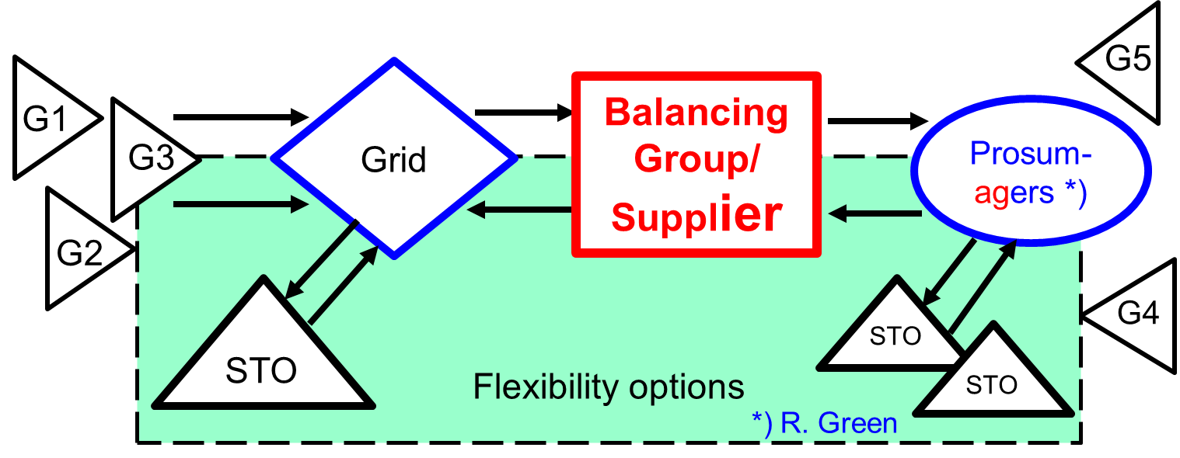 | 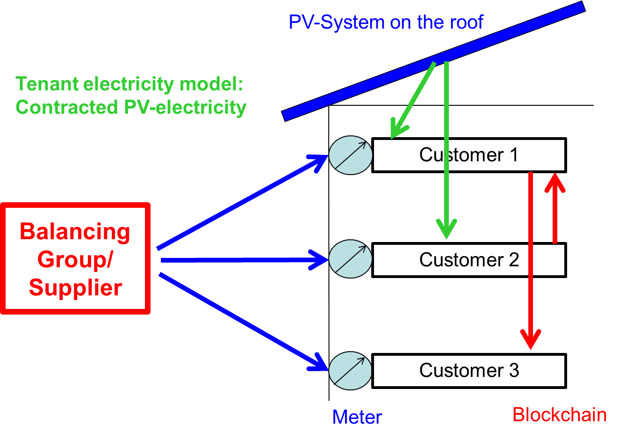
Fig. 3. New thinking in electricity markets: supply-oriented, two-way, very high flexibility and the increasing relevance of „Prosumagers“ | Fig. 4. The tenant electricity model and blockchain: Possible future model for trading and using electricity from decentralized PV rooftop systems

Another major finding is that in a complete market there will be a new core player in the chain, the balancing group (the “supplier”), see Fig. 3. This player is the logical market coordinator of the electricity supply chain and the organizer of competition between the different options. Finally we state that the transition towards a competitive and sustainable future electricity system will be based on the following principle of “new thinking”, which is to accept a paradigm shift of the whole electricity system - including switching from an inflexible and one-way system where variable load is met with changes in generation to a more flexible and smarter system allowing two-way electricity flows – to our understanding – a greater scope for demand participation by consumers needs to be included. In addition, suppliers (or balancing groups) are the most important part of the whole energy service providing chain, see Fig. 3.

In adition, as indicated in Fig. 4 in future decentralized PV systems along with decentral battery storages will play a key role. The astonishing changes in the solar industry epitomize the over-all way PV is heading to. (WNISR 2015): “There seems to be a general recognition that the fall in production costs of RE technologies, particularly of PV, coupled with the expected falling costs of electricity storage will accelerate the transpormation of the power sector.”
And the IEA, which has been tradionally skeptical with respect to RES states in the WEO (2017): “ PV is on track to become the cheapest source of new electricity in most countries world-wide”. One specific approach could be the so-called “tenant electricity model” along with the blockchain. As depicted in Fig. 4 this approach could provide a completely new future model for trading and using electricity from decentralized PV rooftop systems.

Conclusions
Our major conclusions are:
- Revised Energy-only-markets have to be introduced which allow temporarily shortage prices higher than short-term marginal costs and in times of excess electricity negative prices;
- A very important element of such a market will be flexibility options. But these will only be harvested when sufficiently high price signals from the electricity markets trigger these options, when “the exploration principle in the markets work” (Erdmann 2012). Yet this will only be done if the market is not distorted by centralized capacity payments.
- The final conclusion of this analysis is, that it will be necessary to accept a paradigm shift in our understanding of the whole electricity system where no longer the generators are the centre but the balancing groups respectively the supply companies. And finally we state that the evolution of such a creative system of integration of RES in Western Europe may also serve as a role model for electricity supply systems largely based on RES in other countries world-wide.

