Firm Dynamics and Local Economic Shocks: Evidence from the Shale Oil and Gas Boom

Ryan A. Decker. Board of Governors. Federal Reserve System.
Meagan McCollum. School of Finance, Operations Management and International Business. University of Tulsa.
Gregory B. Upton, Jr., Center for Energy Studies. Louisiana State University. 225-578-4140, gupton3@lsu.edu

Overview

Empirical evidence and models of firm dynamics ascribe an important job creation role to new businesses and a particular sensitivity of young firms to economic shocks. Studying the role of entrepreneurs and new businesses in the economy’s response to economic shocks is difficult due to the complicated causal connections between economic growth and firm entry. The recent revolution in shale oil and gas extraction—which created rapid, large gains in economic activity in areas possessing certain geological characteristics—presents a unique opportunity to study the response of firms—both new and existing—to an expansion of economic conditions. Using a diff-in-diff research design, we show that establishment entry accounts for most of the employment growth in shale regions. New firms and new establishments of existing firms account for about a quarter and three quarters of the increased annual aggregate growth rates, respec- tively, relative to plausible counterfactuals; cumulatively, establishments that opened after the shale boom began account for three quarters of total net employment gains from 2007 to 2014, and new firms comprise the majority of the cumulative growth from new establishments. These results have important implications for theories of firm dynamics.

Methods
We use the Census Bureau’s Longitudinal Business Database (LDB), which consists of longitudinal establishment-level microdata covering almost all private non-farm businesses in the U.S.13 The LBD provides annual data on establishment location and detailed NAICS industry as well as annual employment counts (corresponding to the pay period including March 12).
EIA (2017) provides a list of counties that are located within each shale play. We classify counties that are located within the Bakken, Eagle Ford, Haynesville, Marcellus, Niobrara, Permian, and Utica plays as treated areas. We conduct our main exercises on all counties in all shale areas combined; in other exercises we also study each play individually (with its own counterfactual group). For each of these groupings, we first construct a control group of counties through propensity score matching. The variables on which we match are total county employment, the share of firms in the county that are new, the share of employment in the county that is at new firms, the share of establishments in the county that are new establishments of existing firms, the share of employment in the county that is at such establishments, and the share of employment in the county that is at oil and gas establishments (NAICS 211, 213, 324, and 325) and manufacturing establishments (NAICS 31-33); we match based on county averages for 2000-2006. In this way, we construct a control group that is similar to the treatment group in terms of new firm activity, greenfield establishment activity, and activity of the oil and gas and manufacturing industries in the pre-shale time period. The equation below illustrates the commonly used difference-in-differences (DD) style estimation strategy for estimating the effect of shale oil and gas on economic outcomes.
$$y_{ct}=α+δ\left(S_{Shale_{c}}×Shale_{t}\right)+τ_{c}+γ_{t}+ε_{ct}$$
where $y_{ct}$ is the outcome of interest (log total county employment or one of the growth components (described in the full paper) for county $c$ in year $t$. $S_{Shale_{c}}$ is an indicator variable corresponding to counties with shale oil and/or gas activity (i.e. the treatment group) and is zero for non-shale counties. $τ_{c}$ and $γ_{t}$ are fixed effects for county and year, respectively. $Shale_{t}$ is an indicator variable that indicates the years during which shale activity occurred.

Results
Table 4 reports results where the dependent variable is growth component by firm or establishment type (expressed in percentage points). First, note that the “Total” column, in which the dependent variable is the growth rate of aggregate (county) employment, is equal to the sum of columns 1, 2, and 4 or, alternatively, the sum of columns 1, 5, and 6. Column 3, which reports the growth component for all firms age less than 5, is equal to the sum of columns 1 and 2. Column 7 indicates that the shale boom is associated with a 0.9 percentage point increase in annual employment growth rates at the county level. Column 5 shows that greenfield establishments (new establishments of existing firms) account for 0.7 percentage point of the overall increase; that is, greenfield establishments account for about three quarters of the increase in net employment growth rates. Incumbent establishments do not appear to make a net growth contribution. While not statistically significant, column 1 suggests that new firms account for about one quarter of the overall growth effect. The role of entrants is more starkly demonstrated by column 3, which shows that firms with age less than five account for a statistically significant 0.4 percentage point or 40 percent of the total net growth effect. Mature firms (column 4) make a significant contribution as well, though column 5 suggests that this effect is primarily through greenfield establishments rather than growth of existing establishments.

The evidence points to a large role for new and young firms. On the one hand, it is important not to understate the role of incumbent firms. By no means do young firms account for the majority of the employment growth response. However, the contribution of new firms and young firms generally is significantly disproportionate relative to their typical share of activity levels (about 10 percent of employment). Moreover, when scaled by activity we find that the role of new and young firms is even larger, accounting for nearly half of the overall growth effect for both revenue and rigs. Our results are not as dramatic as those found by Adelino et al. (2017), who find that firms age less than two account for 90 percent of the local employment growth response to local demand shocks, but our results are striking nonetheless.

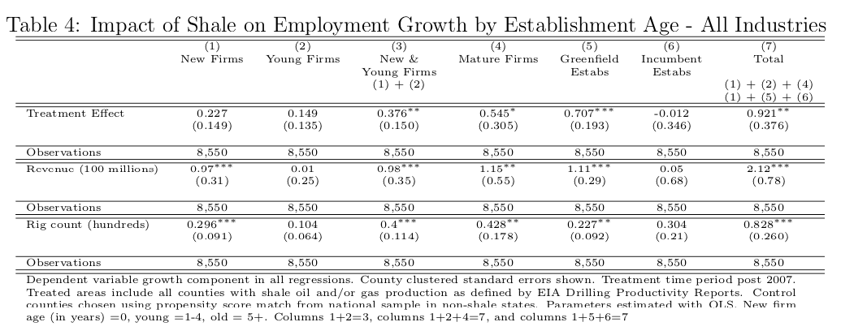

In the full paper, we present effects on cumulative employment growth, as well as a number of robustness checks including alternative control groups and placebo tests.

Conclusions
The U.S. shale boom has given rise to a large literature studying the economic effects of natural resource shocks. We add to this literature by studying the effects of the shale boom on new firms and establishments, adding entrepreneurship and business creation to the list of economic outcomes that are stimulated by natural resource production (i.e., natural resource booms do not appear to only benefit existing business establishments). But our results also have significant implications for the study of macroeconomics. In particular, a large literature in firm dynamics focuses on the role of new business creation in the response of the aggregate economy to broad economic shocks. We show that the growth of aggregate employment in response to the shale boom is, on net, entirely accounted for by new firms and new establishments of existing firms. This finding lends strong support to models of firm dynamics in which, under standard assumptions, the entry margin accounts for a large share of aggregate adjustment. Further, though, our results point to important differences between new firms and new establishments of existing firms (“greenfield” establishments). New firms appear to start small but, as a cohort, grow rapidly. New establishments of incumbent firms appear to start out larger, with a more gradual growth trajectory.

References
Adelino, Manuel, Song Ma, and David T. Robinson, “Firm Age, Investment Opportunities, and Job Creation,” The Journal of Finance, 2017, 72 (3).

