HOW ARE THE BENEFITS OF EUROPE’S DECARBONIZATION DISTRIBUTED?

Kais Siala, Chair of Renewable and Sustainable Energy Systems, TUM, Germany, +498928952747, kais.siala@tum.de
Cristina de la Rùa, Chair of Renewable and Sustainable Energy Systems, TUM, Germany, +498928952747, cristina.de-la-rua@tum.de

Overview
The European Union has set common targets for reducing the amount of greenhouse gas emissions by 2050. This will be partly achieved by the expansion of renewable energy technologies all over the continent. Nevertheless, differences between the individual countries due to their geography, economy, and national policies will persist. Using a linear programming optimization model for capacity expansion and unit commitment, we obtain the cost-minimal design of the European power system until 2050. We also assess the consequences of the power system decarbonization on total emissions, value added, and job creation using a Multi-Regional Input-Output analysis. We then analyze the disparities in the spatial distribution of the new power plants and their benefits, to identify the possible winners and losers of the decarbonization process.

Methods
We use two quantitative models:
- A model for capacity expansion and unit commitment of the power system in Europe, using the open-source linear programming optimization, urbs [1]. Here, each country in the EU28 except Malta and Cyprus, plus Switzerland and Norway are modeled individually between 2015 and 2050. National targets are modeled, when available
- A multi-regional input-output (MRIO) model, with 41 regions. This model depicts the power sector with a higher detail than most input-output models, so that the impact of the technologies can be assessed seperately.
We will look into various scenarios with 80% or 95% decarbonization in the power sector, and with an increase in the power demand due to the electrification of other sectors.
The following aspects will be assessed over time (until 2050) and space (for each country in Europe, and major world regions): the evolution of the share of renewable technologies, the evolution of the power system costs, the number of jobs created, and the value added to the economy. The workflow of the study is displayed in Fig. 1.

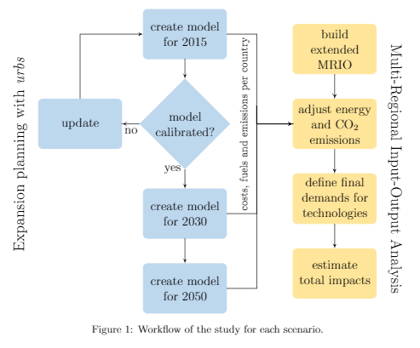

Results
So far, the models have been calibrated for Germany. The analysis will be performed for the other countries as well. Preliminary results regarding the design of the power sector in order to achieve the 95% decarbonization target are displayed in Fig. 2 for Europe as a whole (left) and for Germany in particular (right).
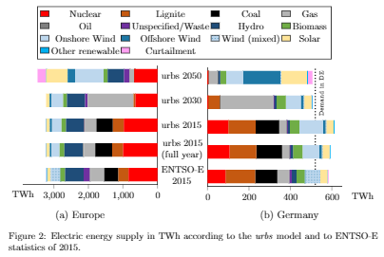
To show the possibilities in displaying the results, Fig. 3 features an excerpt of the results for Germany for the same scenario. When the study is completed for the different countries, we expect to be able to display the spatial distribution of the decarbonization impacts using maps.
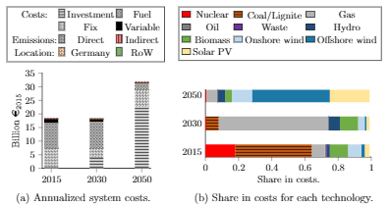

Conclusions

As this is still work in progress, no final conclusions have been derived yet. We will analyze the distribution of the benefits over the countries and see whether a cost-minimizing systemic approach has enough incentives for all countries to engage in the decarbonization process .

References
[1] Johannes Dorfner et al.: urbs: v0.7.3: A linear optimisation model for distributed energy systems, 2018. DOI: 10.5281/zenodo.1228851.

