RESERVOIR TO WIRE PROJECTS IN BRAZIL – HOW TO IMPROVE THE CURRENT REGULATORY FRAMEWORK

Joisa Campanher Dutra, FGV CERI, +55 21 3799 6144, joisa@fgv.br
Luciano Irineu de Castro Filho, The University of Iowa, +1 3193350963, luciano-decastro@uiowa.edu
Edson Daniel Lopes Gonçalves, FGV CERI, +55 21 3799 6246, edson.goncalves@fgv.br
Bruno Cezar Mariano Resende, FGV CERI, +55 21 37996144, bruno.resende@fgv.br
Mirella da Silva Rodrigues, FGV CERI, +55 3799 6146, mirella.rodrigues@fgv.br

Overview
Brazil hasn’t met its great potential in enhancing its natural gas market yet. The difficulties are associated to the intermittent demand of natural gas power plants, as well as to the slow expansion of transportation and distribution networks. However, such slowness is not compatible with both the estimated natural gas resources and the potential demand, justified not only for the residential regions which still do not have access to natural gas, but also for the possibility to convert industrial systems. In order to introduce pillars to develop a more competitive market since the Project of Law 6.407/2013 (“Gas to Growth Program”), associated with Petrobras’ divestment program and the penetration of renewables (Wind and PV) in the Brazilian energy matrix, “Reservoir to Wire” (R2W) natural gas projects can play a key role. These projects are characterized by monetizing the upstream gas production with the creation of thermoelectric plants near the exploratory fields. This is an ideal way to bring competitiveness to the generation process, which is suited to the current demands of the Brazilian energy system - security and reliability of the dispatch that soon will include more renewable intermittent sources.
The main purpose of this paper is to analyze if the current economic regulation meets the criteria of efficiency and financial sustainability for enterprises with the R2W core business. Brazilian current regulation, energy auctions rules and also the models used for physical dispatch do not take into account the main characteristics of R2W projects – they have a good representation only for conventional projects. Thus, they fail to capture the value of this business model and the potential benefits for the entire system. For instance, in gas wells away from pipelines, it may be economically more efficient to convert gas into electricity and commercialize it.
Therefore, in order to check how these elements can improve regulation, we propose some simulation models that incorporate the uncertainties involved on R2W thermal powers plants. They include: i) an integrated physical-financial model for an R2W project that incorporates dispatch outcomes, E&P capital expenditure decisions and other sources of risk; and ii) a model to support decision-making in auctions, with a better representation for R2W projects. As a main result, we can see that current auction rules do not capture the real format of R2W cost function, making this type of enterprise arrangement less competitive compared to other structures.

Methods
Market Design, Scenario Analysis, Monte-Carlo Simulation, Stochastic Dual Dynamic Programming

Results
A conventional natural gas thermal power plant in Brazil has gas supply agreements with a take-or-pay level P_{min} and a different price for consumption higher than P_{min}. We can see this arrangement on figure 1 bellow:

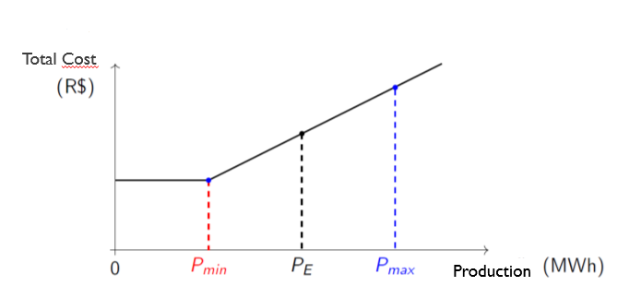
Figure 1 – Current Cost Structure for a Natural Gas Power Plant
However, it is possible to drill a well up to a certain level and, if it is necessary to increase gas production (conditional to dispatch outcomes), another well must be drilled in a manner that the cost structure takes the form of figure 2 below – a piecewise function:
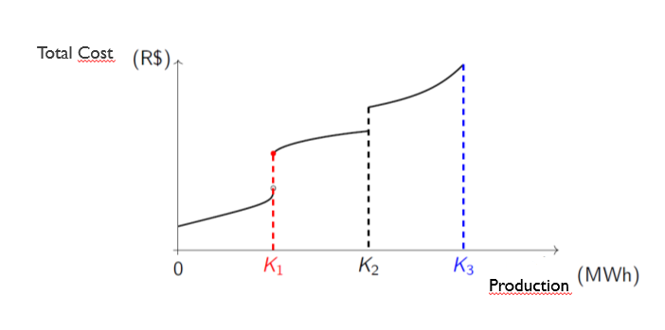
Figure 2 – Real Cost Structure for a R2W Natural Gas Power Plant

Thus, the main result obtained from the implementation of simulation models is that the current format of the Brazilian energy auctions do not display the real structure of costs of a R2W project, distorting the results of the competitive process and leading to economic inefficiency.

Conclusions
R2W ventures have great potential to contribute to the Brazilian energy matrix, given the natural gas onshore availability and the competitive advantages of these types of projects. This research, through economic simulation models, contributes to the theme showing that the regulation of such projects can be improved, increasing reliability and security of energy supply in Brazil.

References
Heeswijk, W. J.A. (2012): "The application of real option analysis on a Gas-to-Wire investment scenario, Master Thesis, Financial Engineering & Management, University of Twente, Electricity Distribution Networks"

Vazquez, M., Amorim, L., Dutra, J. (2016): Development of a Competitive Natural Gas Market in Brazil, CERI-FGV/World Bank policy paper, available in https://ceri.fgv.br/sites/ceri.fgv.br/files/arquivos/development-of-a-competitive-natural-gas-market.pdf

Amorim, L., Danilow, R., Dutra, J., Lima, C., Timponi, G. (2017): Geração termelétrica a gás natural – Comprovação de disponibilidade de combustível (Natural gas thermoelectric generation - Fuel availability verification). CERI/FGV policy paper, available in https://ceri.fgv.br/sites/ceri.fgv.br/files/arquivos/relatorio-geracao-termeletrica-a-gas-natural-2017.pdf.

