Cost Function Analysis of the Power Distribution Network
Mathieu Bordigoni, Enedis, +33 181975393, mathieu.bordigoni@enedis.fr
Laurent Gilotte, Enedis, +33 181974938,laurent.gilotte@enedis.fr

Overview

Most economic analyses on efficient pricing for the electricity grid use strong assumptions on the cost function; often assuming that network costs are fixed. However, estimated tariff consequences on the network and users still remain highly dependent on initial hypotheses ; even if sensitivity studies are carried out more and more frequently [1,2,3].

Inversely, most investments decisions by Distribution System Operators (DSO) are performed on a case-by-case basis; due to local planning constraints such as:
- Diversity of local situations (topography, existing technology, local requirements)
- Incremental putty-clay character of grid investments (historical path dependence)
- Uncertainties on demand (climatic variation, changes in electricity demand, etc.)

In this paper, we present a comprehensive econometric analysis of the total stock of network equipments - by local area - in relation to local consumption behaviors and to the geographical spread of users. The issue is to identify costs associated with the different services provided by the distribution grid: network access – all grid services are provided at the location contracted by the client – guaranteed power and energy transit [4]. An optimal tariff design would reflect network costs related with each of these services, as well as the cost function.

Methods

This study proposes a new methodology to estimate a cost function for the distribution grid that can be used for network pricing with marginal costs.

Firstly, each electrical equipment – transformers, power lines, civil engineering – downstream of a network circuit, either for medium or low voltages networks, is valued at a standard cost [5]. In parallel, consumption data are aggregated at the same circuit level – number and type of customers, annual consumption, subscribed maximum power load, distributed generation installed capacity– as well as data on the network environment as the geographical density per cluster of customers.

As a second step, an econometric model estimates coefficients of the cost function between aggregated demand and network value for each circuit of the distribution grid. A log-log transformation is then performed, with network costs per customer as the explained variable

Results

This method is tested on data from Enedis; the main French Distribution System Operator (DSO). Using more than 2,200 observations at the level of High/Medium Voltage (HV/MV) substations and a random sample of about 10.000 observations at the level of Medium/Low Voltage (MV/LV) substations, it is possible to obtain statistically significant estimates of the amount of network equipment needed to meet local demand.

Slightly more than 90% of the variance in MV network costs, about 80% for LV, is explained by the model (cf. figure 1). In addition, interpretable and consistent coefficients are obtained to differentiate costs impacts by network provided services.

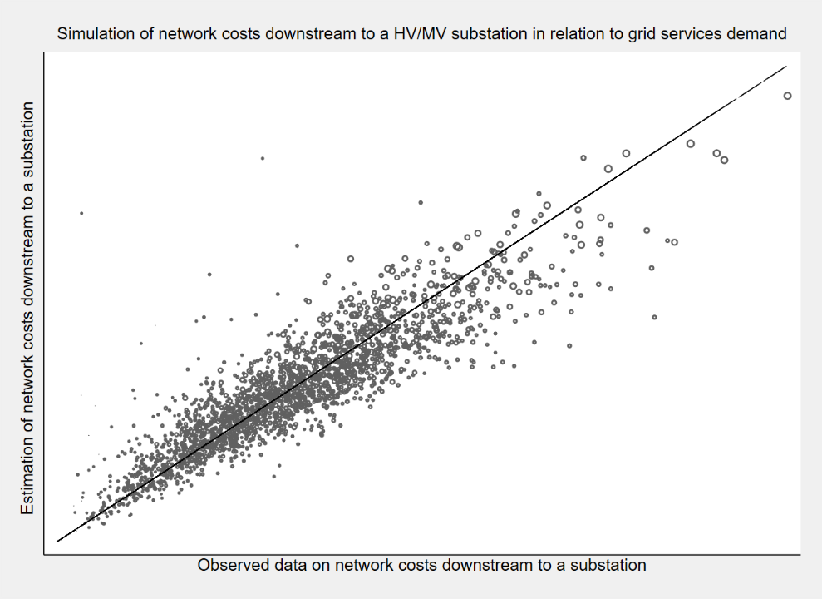
Figure 1 : Observed vs. adjusted data on MV network costs

Results highlight the key effect of customers’ density by cluster on network costs; then only the role of consumption behaviours. In addition, the impact of the annual volume of electricity consumption is statistically differentiated and lower than that of the annual subscribed maximum power load.

Conclusions

In conclusion, the methodology developed in this study provides a relevant assessment of demand side drivers of distribution grid costs for pricing purpose. Results on the cost function can be useful in defining a network pricing that provides an efficient economic signal for each service provided by the grid.

In particular, these results may be useful in studying the equity impact of new electricity uses on the electricity distribution network, as distributed energy resources, electric vehicles and batteries. Further studies may then be added to estimate time-of-use tariffs [4].

References

[1] P. Simshauser, 2016, Distribution network prices and solar pv: Resolving rate instability and wealth transfers through demand tariffs, Energy Economics, 54, 108-122.
[2] R. Passey & al., 2017, Designing more cost reflective electricity network tariffs with demand charges, Energy Policy, 109, 642-649.
[3] T. Schittekatte & L. Meeus, 2018, Least-cost distribution network tariff design in theory and practice, Robert Schuman Centre for Advanced Studies, Florence School of Regulation.
[4] M. Bordigoni & L. Gilotte, 2017, Costing Network Services for Consumers with PV Self-Generation, CIRED Conference, Glasgow, 0777.
[5] H. Crespo & al., 2007, Efficiency Analysis on Electricity Distribution Companies: A Pragmatic and Meaningful Approach to Determine the True Cost Drivers of Utilities, CIRED Conference, Vienna, 0296.

