Power markets in transition: Decarbonization, energy efficiency, and short-term demand response
Christoph Weissbart, ifo Institute for Economic Research at the University of Munich, +49 89 9224 1256, weissbart@ifo.de
Mathias Mier, ifo Institute for Economic Research at the University of Munich, +49 89 9224 1365, mier@ifo.de

Overview
In order keep global warming below 2° Celsius, 195 countries committed to reduce CO₂ emissions in the 2015 Paris Agreement. This translates into a cumulative emission budget for the period 2000-2050 of 1,000,000 mega tons (Mt), so approximately 20,000 Mt each year. Though, annual carbon emissions peaked in 2017 at 36,790 Mt and, furthermore, almost half of the 1,000,000 Mt budget is already emitted. One driving factor for this development are the annual emissions from electricity generation, which increased from 6,300 to 11,700 Mt in the period 1990-2013 and account for on third of total emissions. This is mainly driven by soaring electricity demand, which is expected to increase further due to, e.g., rising household incomes, electrification, and digitization. So far, the promotion of renewable energies is one of the main decarbonization efforts. However, their intermittent supply pattern requires complementing technologies that are either carbon-emitting (gas power), still too expensive (batteries) or are difficult to incentivize (short-term demand response). So that increasing attention is dedicated to long-term demand response measures such as energy efficiency.
In this paper, we analyze how energy efficiency affects the decarbonization of power markets. We develop a framework to integrate short-term demand response and energy efficiency improvements into detailed dispatch and investment models of power markets. The framework is implemented in a model for the European power market in order to find the welfare maximizing level of investments in energy efficiency, quantify its impact for decarbonizing the European power sector, elaborate on the role of short-term demand response, its interaction with the supply side, and quantify the rebound effect in the power market.
The paper is organized as follows: Section 2 describes the model and the underlying optimization problem. Then, we develop in Section 3 the framework to implement short-term demand response and energy efficiency improvements into detailed power market models. Section 4 describes the calibration and Section 5 the results. Section 6 concludes.

Methods
We develop a framework to integrate short-term demand response and energy efficiency improvements into detailed dispatch and investment models of power markets. We assume perfectly competitive firms that decide on production and capacity investments facing carbon prices. Short-term demand response by consumers is reflected by a downward sloping inverse demand function that accounts for demand shedding and shifting. The framework is set up from the perspective of a welfare maximizing central planner. The central planer can invest in the level of energy efficiency and, thus, reduce the amount of electricity necessary to consume the same amount of energy services. A performance parameter translates the investments into actual savings. This parameter is assumed to increase over time to account for exogenous technological progress of energy efficiency on the demand side. Moreover, to account for European decarbonization goals, we implement a carbon constraint of an 80% emission reduction for the period 1990-2050.
We implement this framework into the EU-REGEN model. The model aggregates the countries of the EU28 plus Norway and Switzerland into 13 regions. It also aggregates generators and intra-annual time segments with sufficient resolution to capture dispatch, power flows between regions, and the implications of an increased penetration of intermittent renewable energy sources. The model is solved as an intertemporal optimization through 2050 with 5-year time steps with the intention of simulating a competitive equilibrium.

Results
We find that the welfare maximizing level of energy efficiency reduces electricity demand by 10% in 2050 with playing a heterogeneous role across regions. This depends on a country’s spatial position in the European power market, the quality of its wind resources, and the already existing level of energy efficiency. We obverse a catch-up effect for regions with energy efficiency below its socially optimal level. For regions at the spatial fringe of the European power market, it is harder to balance intermittent generation via transmission, so that they have to rely more on energy efficiency investments. Wind power serves as a substitute for energy efficiency investments, whereas the access to high quality solar power does not hamper investments in energy efficiency. The constant demand reduction from energy efficiency is more similar to the seasonal supply pattern of wind and deviates fundamentally from the diurnal solar irradiation pattern.
Parts of the existing literature emphasize that the interaction between short-term demand response and energy efficiency might lead to much lower energy demand reductions due to the rebound effect. We calculate a rebound effect from energy efficiency investments of 9% in 2050, so that electricity demand is finally reduced by 10% only. This outcome is robust with respect to the depreciation rate, performance, and the assumed rate of exogenous technological progress of energy efficiency. Higher rebounds are calculated for more sensitive short-term demand response. Having in mind that the empirical literature indicates that the short-term sensitivity of electricity demand is rather low, rebounds higher than 30% are extremely unlikely and the future role of the rebound effect, at least in the power sector, seems to be overplayed.
Moreover, we show that also the merits of demand response for the adjustment of the supply side have to be considered. Short-term demand response and energy efficiency enhances the role of wind and solar power and changes the composition of the stack of dispatchable technologies. Energy efficiency reduces demand and, thus, the need for base load generators so that nuclear capacity diminishes. Short-term demand response is offering flexibility to integrate intermittent renewables and, hence, diminishes the role of gas power; bio power with CCS vanishes completely. Coal power stays even longer active because energy efficiency alleviates the emission reduction constraint for the supply side. That allows for a higher emission intensity across the remaining technologies and, thus, increases the relative competitiveness of coal power.
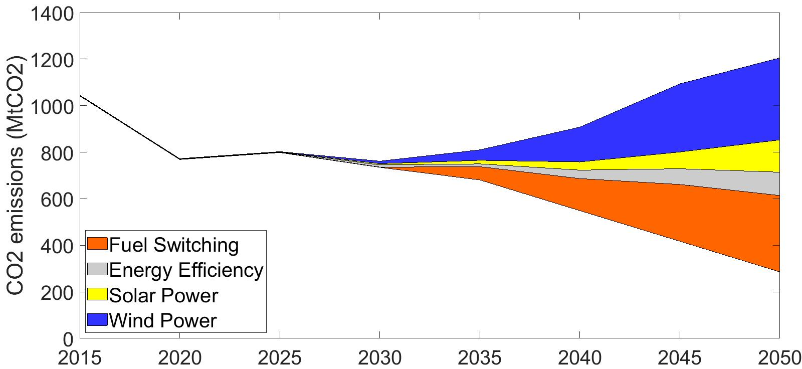
Figure 1: Conbtribution of different abatement channels to climate policy
As Figure 1 shows, investments in energy efficiency contribute with 11% to meet the 80% emission reduction target in 2050 (compared to 1990). Here, renewables (53%) and fuel switching (36%) play dominant roles. With respect to marginal abatement costs, energy efficiency investments and short-term demand response reduce the 2050 carbon price almost equally (reduction of 8 or 9 EUR/tCO₂, respectively). We find subadditive effects when combining both measures (reduction of 22 EUR/tCO₂), so that the final carbon price is at 51 EUR/tCO₂ in 2050. Energy efficiency reduces the base load and, thus, generation of gas power. In turn, gas power remains crucial to the marginal abatement technology because it offers the necessary flexibility to integrate intermittent renewables. As soon as short-term demand response is, additionally, offering the necessary flexibility to deal with intermittency, and not gas power, the carbon price drop is reinforced. Under a tighter climate policy (95% emission reduction), carbon prices are less influenced by demand response (drop from 91 to 82 EUR/tCO₂). The subadditive effect vanishes because the tighter climate target not only limits the generation of gas power but also its role as flexibility option. This makes it necessary to rely on more expensive abatement and flexibility technologies such as bio power with CCS.

Conclusions
This paper provides a framework to implement investments in energy efficiency and short-term demand response into detailed partial equilibrium power market models. We show that, under a 80% emission reduction target, energy efficiency contributes only to 11% of carbon emission reductions. In turn, intermittent renewable energies such as wind and solar power account for the major share of 53%. Consequently, demand response is crucial to the transition of power markets, however, the market integration of renewable energies is still key to the welfare-maximizing path.
This drives focus to extensions and future research. We abstract in our framework from storage as another - besides gas power, transmission, and short-term demand response - major flexibility option. Thus, including storage technologies and endogenizing investments in the ability to respond to prices in the short-term, would allow for also depicting the welfare-maximizing level of flexibility options.

