Empirical evidence from CAISO: Small hydro response to the increasing solar PV
[Rui Shan, Oak Ridge Associated University, 919-308-4035,shanr@ornl.gov]

Overview
We reveal a complementary relationship between small hydro power plants (<30MW) and solar PV in CAISO with empirical evidence. When the solar PV increase its generation or its penetration in the generation system, the small hydro will also increase its generation or penetration. The increase of small hydro happens at the morning and the afternoon peak hours to accomendate part of the ramping need caused by the increasing solar PV. This relationship will act an important assumptions and input for the energy model to devise a roadmap to achieve 100% renewable electricity. It also provides another option to integrate more solar PV into the system, converting non-power dam into small hydro plant rather than installing natural gas plants which is not carbon netrual.

Methods
CAISO discloses their the hourly generation portfolio as one of their daily report on http://www.caiso.com/TodaysOutlook/Pages/Supply.aspx. The data we used is from 2013 Jan 1st to 2017 Dec 31th, accounting for 1826 days.
To analyze the relationship between small hydro generation and solar PV generation, we adopt the Bayesian structural time series model¹ and implement it in R. This model utilizes the Kalman filter for time series decomposition and Spike-and-slab method for variable selection which also indicates the significance.
is the daily time series data of small hydro generation at hour H of the day;
is a regression component, is a 24x1826 matrix and each row represents the daily solar PV generation of a certain hour. is the 24x1 static coefficient matrix.
In a dynamic coefficient setting, will evolve through time following the equations bellow:
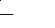
is the trend component and we assume its level components move as random walk but the slope component follows a AR1 process.
is the seasonality components and here in our model, it represents the contribution of each month to the annual cycle. Hence, it could be expressed as following:
The spike and slab method is to assign a prior on the coefficient that the probability of inclusion is zero. When observing the data, the probability of inclusion will be updated. We assume for each time of the trails, only one variable will be included in the model. The iteration limit is 10,000 times.
The same model is used to analyze the relation between the portion of small hydro and the portion of solar PV in the generation mix.

Results

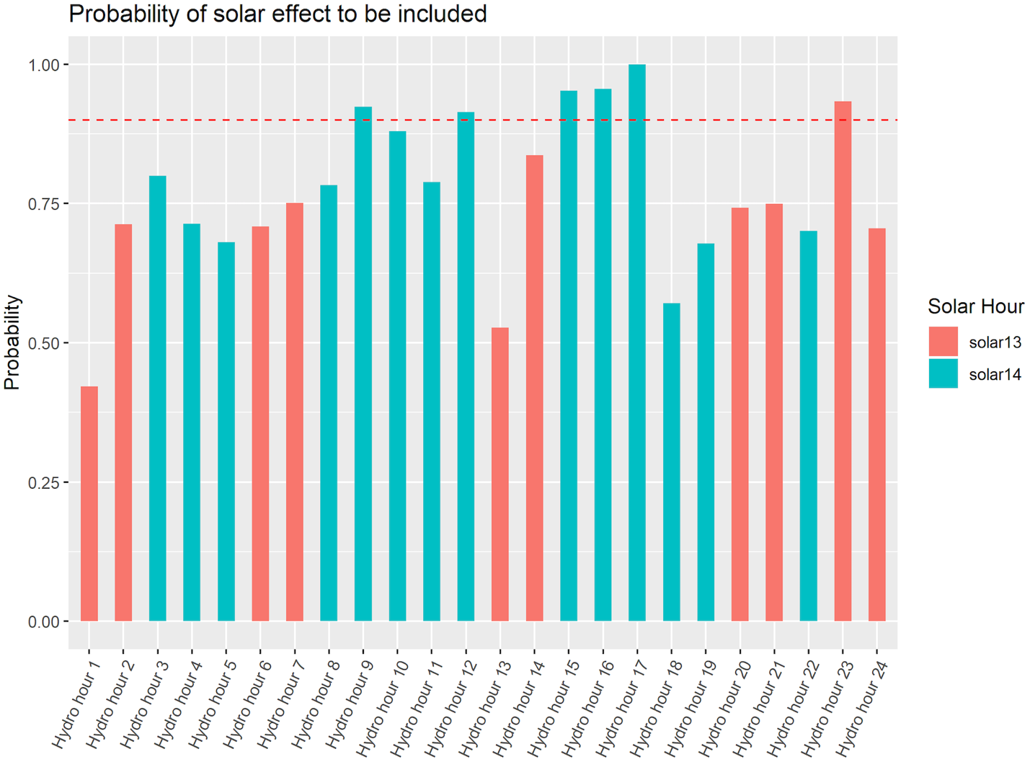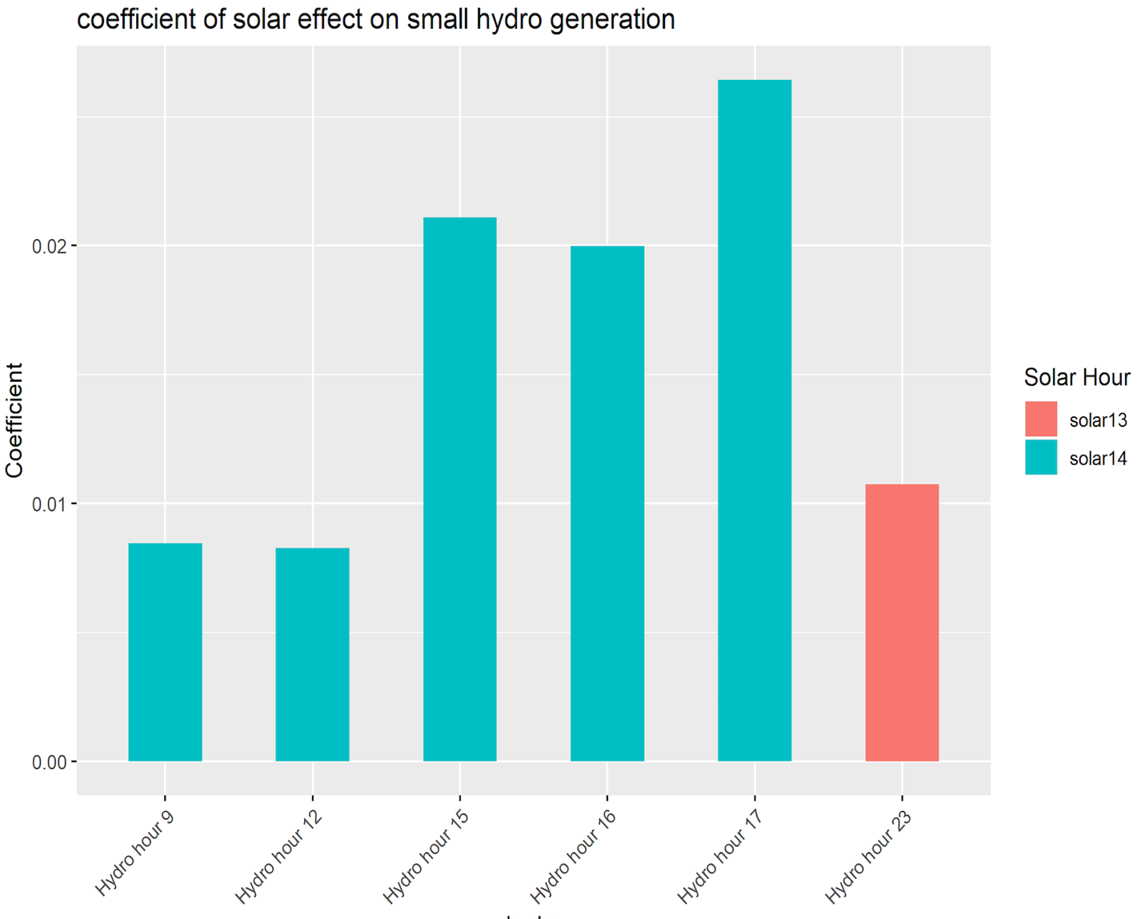
The graph above left summarizes the probability to include the solar PV generation into the model for a better explanation of the variation of hydro generation. It is obvious the small hydro outputs of almost all the hours are associated with the solar PV generation during that day and all the coefficients are positive. The result of variable selection tells that the solar generation at one and two o’clock in the afternoon could provide most necessary information. We conjecture the reason is that the shape of solar generation profile is relatively stable and the peak value and the time of peak value could represent the whole daily solar PV generation profile.We then focus on the hours that the small hydro have more than 90% probability to be associated with solar PV, as shown in the graph above right. The high coefficients from hour 15 to hour 17 stands out. These hours are the time when the net load ramp is likely to begin in CAISO and such ramp needs are largely caused by the solar along with the night demand peak. Before the solar PV generation reaching its peak, the system needs more highly flexible resources and the small hydro generation increase around hour 9 and then quickly decrease around hour 12. Thus, it is understandable that these two significant coefficients for hour 9 and 12. The coefficient at hour 23 is a surprise since we think the solar PV generation would not affect the system operation during the midnight. When we check the system net load error, we find there is a peak of error at hour 23. Such error may have relationship with the daily solar generation and thus it leads to a positive relation of small hydro at hour 23.
One possible explanation for the positive coefficients between the small hydro and solar PV is that they both increase or decrease along with the demand. Therefore, we use the same model with static coefficients to analyze the relationship between the weight of small hydro in the generation mix and the weight of solar PV. Similar to the relationship in total amount of generation, the generation weight of small hydro in almost of all the hours are likely to be affected by the weight of solar PV. One difference is that more hours of solar PV affect the small hydro. Besides the peak hour of solar PV, the common beginning and ending hour of solar PV, eight in the morning and six in the afternoon, have significant effect on the small hydro’s output in the generation portfolio. Another difference is that there are more hours have a high probability (>90%) to be affected. This indicates that the small hydro’s response to solar PV is more significant in the generation portfolio rather than in the amount of generation. Then we look at the hours have at least 90% probability to be affected, we find an evident near term effect that the small hydro’s weight in the generation mix during hour 7 is largely affected by the solar PV’s weight in hour 8. It suggests that if the solar PV generation takes a higher portion at hour 8, small hydro will take more responsibility to prepare for that comparing to some other resources that are not so flexible. The general positive relations during the day, from hour 9 to hour 20, could be explained by the uncertainties caused by solar PV. When the high uncertainties exist, the flexible resources are more preferred in the generation portfolio and small hydro is one of the flexible resources. The small hydro’s weight after sunset is still associated with solar PV’s weight during its peak hours. The reason behind it could be the slow staring process and minimum down time constraints of some plants. When the solar PV’s weight is high, for example at hour 14, some plants are forced to shut down, but when the solar PV decrease, they are not able to restart up so quick and this is when small hydro increase its weight in the generation portfolio.

Conclusions
We find empirical evidence that small hydro increases both the generation and its portion in the generation mix to reponse the system ramping need casusd by increasing solar PV in CAISO. This relation could help to build a better energy model that to devise a roadmap for solar PV integration.

References
1. Brodersen, K. H., Gallusser, F., Koehler, J., Remy, N. & Scott, S. L. Inferring causal impact using Bayesian structural time-series models. Ann. Appl. Stat. 9, 247–274 (2015).

CAISO Final Flexible Capacity Needs Assessment for 2018 https://www.caiso.com/Documents/2018FinalFlexibleCapacityNeedsAssessment.pdf
Flexible Ramping Product Uncertainty Calculation and Implementation Issues, April 2018, https://www.caiso.com/Documents/FlexibleRampingProductUncertaintyCalculationImplementationIssues.pdf

