batteries with market power in electricty markets

Nastaran Naseri; Cologne Institue for Information Systems, University of Cologne; nnaseri@uni-koeln.de

Yashar Ghiassi-Farrokhfal; Rotterdam School of Management, Erasmus University; y.ghiassi@rsm.nl

Wolfgang Ketter; Cologne Institue for Information Systems, University of Cologne; ketter@wiso.uni-koeln.de

Overview
Due to sustainability concerns, several countries plan to keep increasing the share of renewables in their energy mix (Lund et al. 2015). Among all renewables, the expansion in solar and wind power installation seem to be the most promising as sustainable solutions. Especially with their ever-decreasing prices of these two technologies and their small marginal costs, the wolrd-wide capacity of solar and wind increases exponentially fast. The replacement of reliable fossil fuel generators with less predictable solar and wind power generation, however, brings challenges to the elements of the energy systems, one of which being electricity markets.
Intially designed for mostly predictable energy sources, existing electricity systems can only handle a moderate share of renewables, as the dominant energy sources are the predictable and reliable fossil fuel energy sources. However, as the share of renewables increases, the uncertainty of supply increases and this might lead to market manipulations, inefficiency, or increased carbon emissions (Ghiassi, Ketter, and Collins 2017).
One approach to address the challenges of renewables is battery storage. Batteries are compatible to respond instantaneously when wind and solar output is low. Furtheremore, batteries are well-suited to store energy when there is peak in supply and release it when energy is of greatest value.
In order to improve the market efficiency, battery storage capacity should be considerable with respect to the total capacity of the market. For such large battery sizes, there is an inherent trade-off when batteries are used to imrpove market effiecieny. On the one hand, batteries reduce market prices and energy uncertainty, and price fluctuations; hence, helping market efficiency. On the other hand, such a large battery capacity will have market power; hence, might induce strategic behavior and loss of market efficiency. Indeed, wholesale electricity markets are susceptible to exercise of market power, particularly at times of tight supply and demand balance (Biggar and Hesamzadeh 2014).
Inspired by this inherenet trade-off, in this study, we seek to find out whether or not battery is indeed helping market efficiency and under what conditions this holds true. To do so, we examine the role of batteries in electricity markets from two perspectives: market owner and battery owner. The short-run objective of the market owner is market efficiency and from the perspective of battery owner, profitability is what matters. To be more precise, we develop a framework to investigate the role of batteries in improving market efficiency in presence of different levels of market power. Aditionally, we analyze the profitability of price arbitrage for battery in the day-ahead electricity market.

Methods
We begin by formulating the operation of battery in the day-ahead electricity market. Suppose that the battery owner only participates in the day-ahead market for price arbitrage. Therefore, the battery gets charged during the time slots that buying price is low and discharged when the selling price is high. The objective of storage agent is to maximize the profit (denoted by $π$) which is the revenue obtained from selling energy minus the cost of buying energy, while the depreciation cost of the battery is considered when selling. Mathematically speaking, this can be expressed as
$$Maximize π= \sum_{t=1}^{T}{\left[P_{t} \left(E_{t}^{d}-E_{t}^{c}\right)-CE_{t}^{d}\right]}$$
Where, $E_{t}^{c}$ and $E_{t}^{d}$ represent energy transfer to and from the battery at time t (MWh), respectively. $P_{t}$ is the day-ahead price accunting for battery arbitrage at time t (Euro/MWh), and $C$ is the battery depreciation cost (Euro/MWh). The problem is restricted by multiple constraints. The price per unit of energy in the electricity market is affected by the energy quantities of the battery. This can be expressed by
$$P_{t}= P_{t}^{*}- ρ\left(E_{t}^{d}-E_{t}^{c}\right)$$
Where, $P_{t}^{*}$ is day-ahead price without battery arbitrage at time t (Euro/MWh) and $ρ$ represents the slope of the demand curve. We assume that demand is inelastic and allocated in full in the forward market. The latter assumption stems from the fact that market owner in electricity markets typically schedule most or all expected demand in the day-ahead market (Ito and Reguant 2016).
Physical constraints of operation of battery naming battery charge and discharge efficiency, maximum depth of discharge, the bound of energy flowing in/out of the storage, have been considered. For our analysis we used day-ahead prices are based on Gemany day-ahead electricity prices for 2017. Moreover, we integrated the scale of market power with the size of battery.

Results
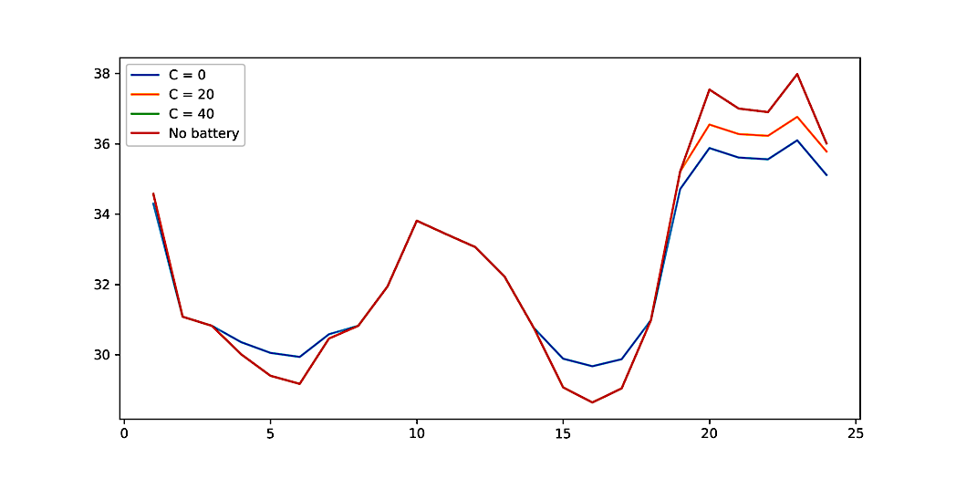
Here, we discuss some of the results of our framework on market efficiency and profit of price arbitrage. We consider the size of battery as a ratio of average demand, which ranges from 5% to 70% of average demand of the market. With the current prices, the depreciation cost of battery is higher than the average of market price. It can be shown that in such scenarios price arbitrage is not profitable and in this case battery does not influence market efficiency. It can also be shown that if the depreciation cost of the battery is less than the average market prices, the profitability is linearly proportional to the size of the battery. Thus, we exclude any profitability visualizations here and only focus on efficiency results in the sequel.
Figure 1- Price after arbitrage when share of battery in the market is 30%
Time Slots (Hour)
Price (Euro/MWh)
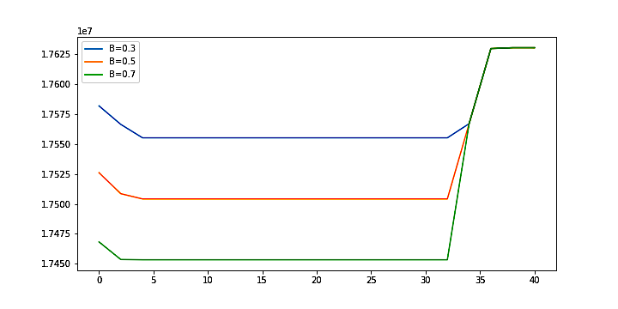
Figure 1, shows the impact of battery arbitrage on market prices for different depreciation costs (0, 20, 40 Euro/MWh) compared to the case where there is no battery. When the cost of battery is very low (e.g., see the extreme case of $C=0$), battery increases the price when it is low and decreases the price when it is high. However, when the cost of battery is less than the average of market price (see $C=20$), there is a trade-off for battery and it arbitrages when the spike in price is greater than the depreciation cost. This happens more often with the maximum peak prices (rather than minimum peak prices). Therefore, battery is more likely to lower the price. Our results show that price arbitrage of battery decreases the peak to average ratio of price from 1.16 to 1.11, whereas, the minimum to average ratio of price decreaseses from 0.88 to 0.91 when the depreciation cost of battery is ranging from 0 to 40 Euro/MWh.
Figure 2- Cost of deliverying energy for the market owner
Depreciation Cost of Battery (Euro/MWh)
Cost of Energy (Euro)
As depreciation cost of battery has substantial impact on the behavior of battery owner and on market efficiency, here we analyze this impact with more detail. Figure 2, represents the cost of deliverying energy with respect to depreciation cost of battery for different share sizes of battery (30%, 50%, 70% ). Cost of deliverying energy is considered as the measure of market efficiency. The lower the cost of energy, the higher the efficiency of the market. This plot shows that when the battery price falls below the average market price, battery improves the market efficiency. However, adding battery with very low depreciation cost has negative impact on market efficiency.

Conclusions
This work has several implications. In particular, we find that adding a large-scale battery to the day-ahead electricity market has a trade-off between the reduction of price volatility and exercise of market power. Despite of the impression that battery improves market efficiency, strategic behaivior of large-scale battery with market power does not help market efficiency all the time. The strength of the contradicting forces in this trade-off varies with the depreciation cost of the battery with respect to average market prices.

References
Biggar, Darryl R., and Mohammad Reza Hesamzadeh. 2014. The Economics of Electricity Markets. John Wiley & Sons.
Ghiassi, Yashar, Wolfgang Ketter, and John Collins. 2017. “Designing a Battery-Friendly Electricity Market.” ICIS 2017 Proceedings, December. https://aisel.aisnet.org/icis2017/IT-and-Social/Presentations/9.
Ito, Koichiro, and Mar Reguant. 2016. “Sequential Markets, Market Power, and Arbitrage.” American Economic Review 106 (7): 1921–57. https://doi.org/10.1257/aer.20141529.
Lund, Peter D., Juuso Lindgren, Jani Mikkola, and Jyri Salpakari. 2015. “Review of Energy System Flexibility Measures to Enable High Levels of Variable Renewable Electricity.” Renewable and Sustainable Energy Reviews 45 (May): 785–807. https://doi.org/10.1016/j.rser.2015.01.057.

Data from http://www.epexspot.com/en/market-data/dayaheadauction

