Stable coalitions among NPCC’s power systems: A cooperative game with externalities
Sébastien Debia, HEC Montréal, sebastien.debia@hec.ca
Pierre-Olivier Pineau, HEC Montréal, pierre-olivier.pineau@hec.ca
Jesús Andrés Rodríguez, HEC Montréal, jesusandresrodriguez@ingenieros.com

Overview
The Northeast Power Coordinating Council (NPCC) comprises American states and Canadian provinces (New England, New York, Ontario, and Québec). Most of these jurisdictions have very ambitious decarbonisation goals. For example, the Canadian government enacted 80% of CO2 emissions by 2050 w.r.t. 2005 levels, and New York and the New England states are currently evaluating this option and also have binding short term targets. These emission objectives go beyond the NPCC, for instance, the European Commission recently enacted similar goals.
One way of contributing to CO2 emission reduction is to foster integration between neighbouring power systems. In allowing to take advantage of systems complementarity, such as peak-load asynchronisms and the comparative advantages of production in each region, the mitigation effort can be achieved at a reasonable cost. Hydropower storage, which is abundant in Québec, can balance intermittent energy sources, e.g. wind and solar, with no associated emissions. But for this hydropower storage to be optimally used, investment in interconnection capacity is needed, as well as institutional rules enforcing coordination among the sub-regions.
If a better integration intuitively creates wealth, the issues pertaining to the distribution of this wealth are particularly difficult. Merchant investments are structurally suboptimal, and parties often fail to reach an agreement for regulated investments (Littlechild, 2012).
In this research, we aim at defining a fair allocation of the wealth created through cooperation. Cooperative game theory provides a set of tools to assess whether a coalition is stable—the core of the game—and how to redistribute the gains amenable to such a stability. The Shapley value is the most used single-valued allocation, as it is easily computable and is interpretable as an average marginal contribution (see Kristiansen et al. (2018) for a recent application to interconnections). The standard theory is however hardly applicable to power systems since electricity trade generates externalities: changing the pattern of trade between two countries has repercussions over the entire network and modifies the payoff of each region in the system. Hence, the value of a coalition is dependent on the externalities created by the left-out players, and especially on how they organize: their partition.
This research is the first to apply cooperative-game-with-externalities theory in a network of connected power systems. We analyse the impact of externalities on the stability of the grand coalition for investment in interconnections and provide an institutional framework to improve the stability of such coalition, namely by sharing capacity reserves among the players.

Methods
When facing externalities, the worth of a coalition is not unique anymore. Because of this multiplicity, the main notions in the standard cooperative game theory cannot be straightforwardly extended. The core is partition-based, in that it is defined after selecting a particular partition (Abe and Funaki, 2017). For example, the optimistic core selects the partition which maximizes each coalition’s payoff. It is the smallest partition-based core, in that it is contained in every other core. Reversely, the pessimistic core is the largest partition-based core, and it contains every other core.
We compute two extensions of the Shapley value to partition function games: the externality-free value (De Clippel and Serrano, 2008) and the average value (Macho-Stadler et al., 2007), and verify if these values are in their own partition-based core, provided the latter is non-empty.
The worth of each coalition for each partition is computed on the five-node representative model of the NPCC region in Debia et al. (2018) with an 80% emission reduction (base 1990) constraint. Neighbouring nodes can cooperate in two ways. First, they can invest in interconnection between them (physical integration). Second, they can cooperate by sharing capacity reserves (institutional integration). In this case, connected players cooperate if they take into account each other exports in their capacity mechanism.
Each node’s cost is computed by taking into account investment and production costs minus their net exports revenues. The worth of each coalition is the sum of the net costs of the players in the coalition, computed with respect to the status-quo (no cooperation). The nodal cost under the grand coalition scenario is the market allocation.

Results
Our analysis consists in three cooperative games: interconnection only, sharing capacity only, and both. Table 1 displays the worth of the grand coalition in these games in billion dollars per year. To invest in interconnection alone has little value compared to the sharing of capacity reserves. The two games are good complements, as the joint cooperation the two axis of integration is greater than the sum of each. None of these game is convex.

Table 1: Worth of the Cooperative Games
Game | Interconnection | Capacity | Full
Worth of the game | 0.14 B$/year | 0.67 B$/year | 1.66 B$/year

On top of a modest worth, the interconnection game has little stability: over the partition-based cores computed, only the externality-free core is non-empty, but the externality-free value is not in this core. On the other hand, the capacity game stability is very robust: the optimistic core is non-empty, and all the computed values, including the market allocation, are in that core. The full game’s stability is a mixed result: the optimistic core is empty, but the externality-free and the average cores are non-empty with their associated value within them. The market allocation is only in the externality-free core.
Figure 1: Values for the three games
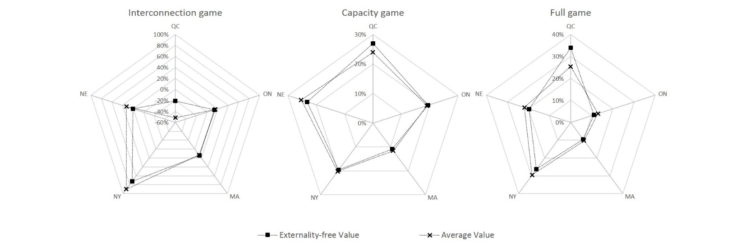
Figure 1 displays the externality-free value—which get rid of the effect of externality—and the average value—which consider the average over a probability distribution of the externalities—for the three games. The comparison of these two values provides a measure of each region’s sensitivity to externalities. Québec, which is the structural exporter in our model, suffers on average from negative externalities, and is consequently more interested in the grand coalition. New York and New England, which are structural importers in the model, profits on average form positive externalities, and have less incentives to form the grand coalition.

Conclusions
Regulated investment in interconnection needs agreements, which is hardly attainable in practice. We illustrated this case with cooperative game theory: the interconnection game stability suffers heavily from externalities. In the setting of our numerical optimization, we show that sharing reserve capacity on the other hand is much more stable, is more robust to externalities, and provides a greater value. It can further be used as a first step for investment in interconnection.

References
Abe, T., Funaki, Y., 2017. The non-emptiness of the core of a partition function form game. International Journal of Game Theory 46, pp.715–736.
Debia, S., Pineau, P-O, Rodríguez, J. A., 2018. The cost of decarbonizing the Northeast electricity sector, working paper.
De Clippel, G., Serrano, R., 2008. Marginal contributions and externalities in the value. Econometrica 76 (6), pp.1413–1436.
Kristiansen, M., Muñoz, F. D., Oren, S., Korpås, M., 2018. A mechanism for allocating benefits and costs from transmission interconnections under cooperation: A case study of the North Sea offshore grid. The Energy Journal 39 (6), pp.209–234.
Littlechild, S., 2012. Merchant and regulated transmission: theory, evidence and policy. Journal of Regulatory Economics 42, pp.308–335.
Macho-Stadler, I., Pérez-Castrillo, D., Wettstein, D., 2007. Sharing the surplus: An extension of the Shapley value for environments with externalities. Journal of Economic Theory 135 (1), pp.339–356.

