A Renewable energy roadmap for transportation and heating sectors in apec region
Sih-Ting Jhou, Industrial Technology Research Institute, +886 2 87720089 ext. 803, tarcy@itri.org.tw
Kung-Wen Chiang, Industrial Technology Research Institute, +886 2 87720089 ext. 802, chiang026@itri.org.tw

Overview
The Asia-Pacific Economic Cooperation (APEC) member economies, the world’s largest producers and consumers of energy, are advancing new measures to double the share of renewable energy in the region. APEC Leaders’ Meeting in 2014 and the APEC Energy Ministers’ Meeting in 2015 set the goals to double the share of renewable energy in the overall energy mix by 2030, for achieving sustainable and resilient energy development within the Asia-Pacific.

Aligned with the goal of doubling the share of renewable energy in the energy mix of the APEC region, this paper aims to assess the gaps in the development of renewable energy technologies and provide a strategic roadmap to address these gaps for non-electricity sector including transportation and heating secotrs.

In 2015, the transportation sector accounts for 75% in the global final energy consumption, and amount the total consumption in global transportation sector, 95.5% form fossil fuel, 3.1% from renewable energy, 1.6% form bioethanol, 0.8% form biodiesel, 0.4% form other liquid biofuel, 0.01% from Biomethane, and 0.3% from renewable energy electricity. (IRENA, 2018) In the APEC region, building, agricultural, and industrial sector are main consumers for heat. Total final consumption expected to increase gradually form 195 Mtoe in 2013 to 251 Mtoe in 2030, and account for 37% in total energy consumption. The demand in industrial sector in 2010 reached 94 Mtoe which is slightly higher than 93 Mtoe in building and agricultural sector. However, in 2030 the growth rate in demand of industrial sector slows down and exceeded by the demand from building sector, which is 128 Mtoe(APERC, 2016).

A roadmap outlines a set of policy recommendations to accelerate renewable energy development in transportation and heating sectors in the APEC region. First of all, this paper introduces the current renewable energy status, evaluates the development challenges, and identifies the gaps in and key factors of renewable energy development. Afterward, this paper identifies different dimensions and strategies to foster renewable energy development transportation and heating sectors in the APEC region.

Methods
The paper involved a broad review of evidence on heating and transportation sectors across APEC economies and detailed case studies on economies that appeared to offer the greatest potential for learning. Following an initial review of the literature, the paper presents the overall development of renewable energy in heating and transportation sector in APEC region, analyses the gap for achieving the renewable energy doubling goal of APEC for non electricity sector based on a quantitative data search, provides some case study based on a broad systematic search of the academic literature, and finally develops a strategic pathway with a work program of priority for policy recommendation towards the aspirational goal of doubling the share of renewables in the APEC energy mix.

Results
According to the statistic from APEC APEC Energy Demand and Supply Outlook 6th Edition, the target for reaching APEC renewable energy doubling goal in 2030 for non electricity sector is 170 Mtoe, which indicates that based on the BAU scenario in 2030, the whole region has to increase 31 Mtoe for filling the gap.

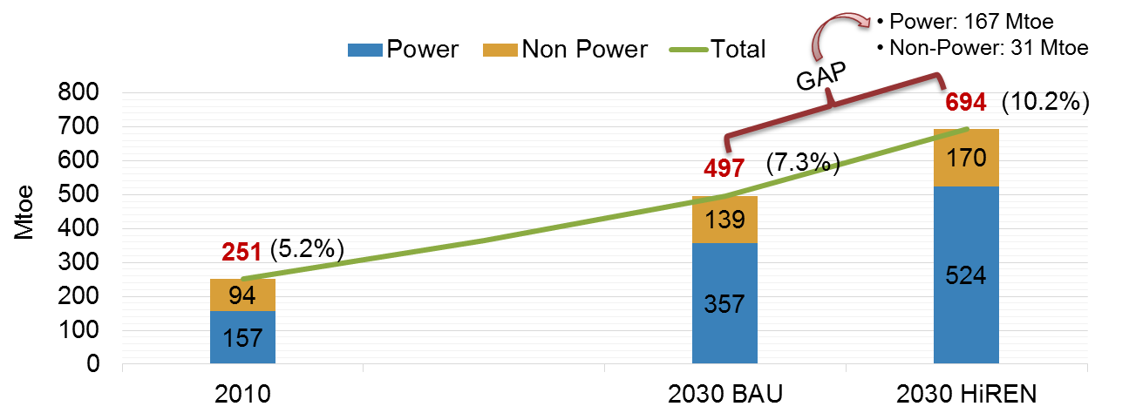
source: retrieved from APERC （2016）

The findings of this project indicate that when APEC economies develop renewable energy, they are faced with a number of arduous challenges which include in differenent dimensions such as policy aspect, market aspect, technology development and capacity building. The policy recommendations of this paper propose various strategies to deal with such challenges.It is strongly believed that these strategies would stimulate the usage of renewable energy in tranporation and heating sectors. In this way, the APEC region could achieve the goal of doubling the share of renewable energy generation by 2030 and move towards a sustainable future.

Conclusions
APEC economies have conceus on reaching the regional renewable energy development target; however, the regional target can not be achieved if APEC economies’s only achieve their domestic targets. It needs extra efforts to accerlate the renewable enegy development to achieve the regional target by 2030. Even non-electricy sector is relatively small amount compared to electiry sector, it plays an important role for achieveing the regional target, especially when the regional target could not be achieved even all APEC economies’ domestic targets are achievied.

This paper provides the policy recommendations propose various strategies to deal with such challenges. Several member economies still rely highly on fossil fuels to meet energy demand in transportation and heating sectors. Therefore, amending renewable energy laws and strengthening renewable energy policy commitments are avenues to improve policy consistency. Furthermore, it is also important to make the integrated policies, so the action plans will have comprehensive legal framework to support. Additionally, providing refundable and/or non-refundable investment tax credits, grants, and venture capital equity would help overcome the issue of capital cost of renewable energy development. Moreover, the APEC region has entered a new era of renewable energy. APEC economies should propose various renewable energy development plans to support the goal of doubling the share of renewable energy. Additionally, the APEC economies should review their renewable energy development goals periodically.

References
- "APEC Energy Demand and Supply Outlook 6Th Edition". 2016. 1. APERC.
- "District Energy Systems in China Options for Optimisation and Diversification". 2017. IEA Series In Support Of IEA–China Energy Co-Operation. IEA, Tsinghus University.
- "Heating Without Global Warming, Market Developments and Policy Considerations for Renewable Heat". 2014. IEA.
- "Renewable Energy in District Heating and Cooling". 2017. REMAP. IRENA.
- "Renewable Heat Policies, Delivering Clean Heat Solutions for the Energy Transition". 2018. Insight Series 2018. IEA.
- "Renewable Thermal in State Renewable Portfolio Standards". 2018. Clean Energy States Alliance.
- "Tracking Clean Energy Progress". 2018. Iea.Org. https://www.iea.org/tcep/.
- Biodiesel Magazine. 2016. "Biodiesel Presence In Future EU Policy Revealed In Leaked Draft", , 2016. http://biodieselmagazine.com/articles/1874430/biodiesels-presence-in-future-eu-policy-revealed-in-leaked-draft.
- Cheng, Jay J., and Govinda R. Timilsina. 2011. "Status And Barriers Of Advanced Biofuel Technologies: A Review". Renewable Energy 36 (12): 3541-3549. doi:10.1016/j.renene.2011.04.031.
- IRENA, OECD/IEA and REN21. 2018. "Renewable Energy Policies In A Time Of Transition". IRENA, OECD/IEA and REN21. https://www.irena.org/-/media/Files/IRENA/Agency/Publication/2018/Apr/IRENA_IEA_REN21_Policies_2018.pdf.

