Overview
Providing reliable service is crucial, yet challenging for some service sector, due to its inherent characteristics. Services as a commodity differ from tangible goods in a sense that its value perishes with time and its short-term supply capacity is limited. The combination of perishability and capacity constraint makes the resolution of supply and demand imbalances difficult to acheive. Pricing strategies, such as yield management and dynamic pricing, have been widely used in these sectors to reduce economic loss upon occasions of excessive supply or demand. Demand response resource is gaining increasing attention from electric utility regulators as a reliable and cost-effective means to control peak demand. Demand response resource can be dispatched regularly on the basis of economic rationale or instead sporadically for reliability concerns. Reliability demand response is a contingency plan to ensure power grid reliability in real time by promoting market participants to curtail electricity usage.
The Korean reliability demand response program has been implemented since 2014, currently hosting more than three thousand industry customer participants. Despite the program’s continued growth, its reliability of the program is under threat from frequent instances of some customers failing to dispatch the contracted capacity. Figure 1(b) shows that demand responses for the most part failed, falling short of the reference capacity. Substantial performance variation among customers with similar Customer Baseline Load points to the heterogeneity in their business practices and conditions as a possible reason behind the failures (Figure 1(a)). In this circumstance, a uniform incentive rate for demand response would make a subset of customers necessarily underperform the contracted capacity. We propose and analyse an economic model that captures the principal-agent relationship present in the demand resource contract between a regulated utility and its customers.
Figure 1.

Contract Design for Service Reliability Management based on Demand-Side Flexibility:
The Case of Power Reliability Demand Response Program
Eunsol Cho, KAIST College of Business, Republic of Korea, +82 10 9962 4090, playtime@kaist.ac.kr
Jiyong Eom, KAIST College of Business, Republic of Korea, +82 10 8612 1606, eomjiyoung@kaist.ac.kr
(a) Abatement and CBL per industry category (b) Contracted capacity and actual abatement per demand resource ID

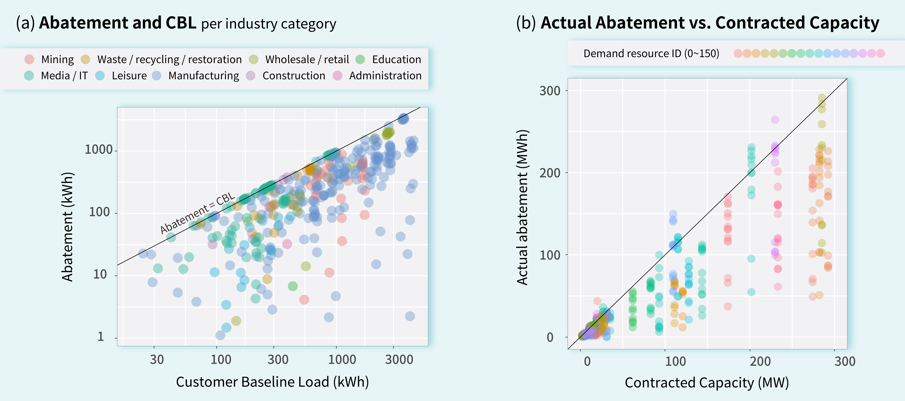

Methods
In our stylized model, the electric utility regulator (principal) provides customers (agent) with electricity, where customer type θ ∈ [θ_{L}, θ_{H}] is unknown to the principal. Each customers make utilty-maximizing decision on energy consumption. Utility of customer i with θ_{i} is described as U_{i} (q, p, θ_{i}) = θ_{i}v(q) – pq, where v(q) is valuation function of electricity, θ_{i} is customer i’s individual coeffient of the valuation function, and p, q are unit price and electricity consumption, respectively. For analytical tractability, the valuation function is specified as v(q)=aq²+bq, which satisfies the usual conditions of v(0)=0, v’(q)>0, and v’’(q)<0. It is also assumed that customers participating in the program experiences the utility increase by the amount of incentive payment, I(Δq). The customer’s utility before and after program participation can be expressed by
For customer i to enter the program, individual rationality (IR) constraint, ΔU = U_{i,before} – U_{i,after} > 0, should hold. The principal determines the incentive function that maximizes its economic returns from market operation while making sure that a higher return can be achieved with the demand response program. The problem can be defined as the following, where C(Q) is electricity generation cost when total demand is Q.
As customer type θ_{i} is unkown to the principal, the first-best outcome to customize the incentive rate cannot be attained. We begin by setting up a simple linear incentive and fixed fee arrangement, that is, I(Δq) = –I_{p}Δq + F, where I_{p} is performance incentive rate and F is fixed fee. The consumption decision of the customer under the contract is given by
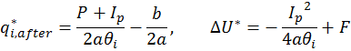
Therefore, in case of negative F, only customers with high enough θ_{i} would enter the program due to the IR constraint. The incentive function can be extended to the following piece-wise linear incentive function, which reflects the current arrangement made by KPX for reliability demand response program.
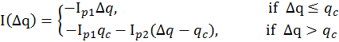
where incentive rate differs in the interval below and above contracted capacity, q_{c} (assume q_{c} ≈ δq_{i,before}). By solving consumer’s utility function under the IR constraint, we gain insights into the customers’ decision of participating and performing in the program. In particular, we analyze the customers’ self-selection of two incentive menus(I₁,I₂) with I_{p1}, I_{p2}, and I_{p1}’, I_{p2}’, both with fixed fee F, admitting that it results the second-best outcome.
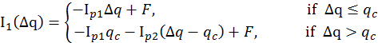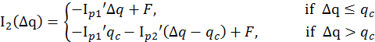

Results

We begin by analysing the piece-wise linear incentive function. Our result indicates that θ_{i} determines whether i would fulfil the contracted capacity or not, among customers who have joined the program (Figure 2(a)). Confirming our intuition, consumers with high θ_{i,} who value electricity more and have higher opportunity costs, fail to reach q_{c}. Moreover, while incentive rate(I_{p1}) decides on the cutoff of θ_{i} determining the success or failure to reach q_{c}, the value of F only affects the customers’ participation decision. When it comes to the two incentive menus, where the customers self-select one of the two menus, our result indicates somewhat different response by the customers.

When I_{p1}’ is bigger than average of I_{p1} and I_{p2}, consumers who failed to reach q_{c} in two menus but succeeded in the single menu appear in the middle range.
Figure 2. Behaviors of consumers with different θ_{i}
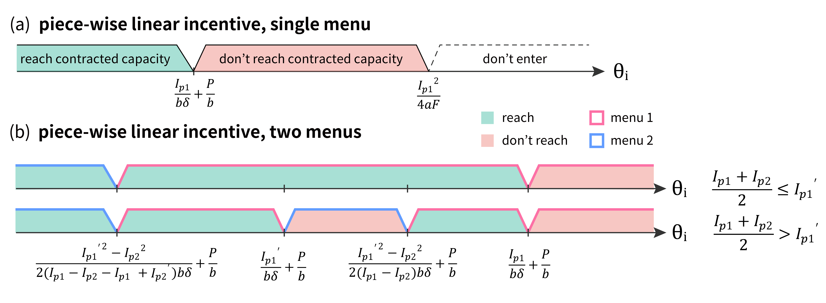

Conclusions
Demand response program is a promising strategy to achieve grid reliability in a cost-effective way. However, data from reliability demand response program in Korea suggests that the current incentive structure lacks in consideration of customer heterogeneity. A simple principal-agent model has been employed to investigate the customers’ economic response to various incentive arrangements. The results show that incentive rate and fixed fee can play distinct roles in eliciting the customers’ demand resources. Moreover, our extension to the two menus indicates that with different incentive setting, the same client can either succeed or fail to reach the contracted capacity. In the future, we plan to explore the model in a more general setting and to suggest a socially optimal contract that would achieve economic efficiency while at the same time promoting service reliability.

