What Factors Drive Private Capital Flows to Low-Carbon Energy Transition in Developing Countries?

[Venkatcahalam Anbumozhi, Economic Research Institute for ASEAn and East Asia, Jakarta, Tel: +628119106874 Email: v.anbumozhi@eria.org]
[Kaliappa Kalirajan, Australian National University, Canberra, Tel: +61416984815 email Kaliappa.kalirajan@anu.edu.au]

[
Overview
This paper studies the drivers of private capital flows to developing countries for low carbon energy transition and the apparent barriers to meet the Paris Agreement targets. Past studies and econometric results reveal that the portfolio flows to a fast emerging country tend to rise in response to increase in the current apparent deficits;a rise in FDI flows; high percapita income and growth performance. Once these variable for accounted for location and regional factors did not seem to influence the private flows. On the other hand, capital flows across the region into low carbon energy sectors such as renewable energy and energy efficiency is shaped by several facors which include, perceived risks of making investments or developing projects due to changing/inconsistent government policies, a lack of access to de-risking financing mechanism, and minimal knowledge and communication between borrowers and lenders. Public finance, including international financial institutions appear to have guaranteeing role in response to volatility of private flows and the barriers attached to it.

Methods
A survey to support a quantitative analysis of the factors that paper to drive various types of capital flows into the developing countries of South and East Asia is conducted. .In order to leverage private finance, it identified the needs, barriers and solution to support low-carbon investments. This paper will elaborate the factors that drive private capital to these developing in three arts. First, this paper will evaluate the three main findings from Borrower and Lender reported answers through economientric analysis of capital flow into the countries . Second, this paper will identify the risks and barriers (including economic, financial, technical, and regulatory aspect) to scale up private low-carbon energy investment. Lastly, the paper will see innovative solution that will unleash the potentials of private finance supporting the transition pathway.
The survey questions were categorized into four different sections: (section 1) participants’ background; (section 2) supply side or lenders; (section 3) demand side or borrowers; and (section 4) regulatory framework. They aimed to capture a diverse spectrum of information pertaining to the low-carbon technology financing market. Section 1 aims to identify general characteristics of all participants to profiling the respondents. It contains general information, included information on industry, ownership, position of the respondent, sector focus, asset holdings, and firm size. Section 2 classified the respondents from non-bank financial institutions (private equity and venture capital), commercial banks/credit agencies, international financial institutions, and international investors, which further can be categorizes as Lenders. Section 3 questions tried to identify the significant obstacles that firms face in accessing funds and investment for their low-carbon projects, and ways to further stimulate low-carbon investments. The section focuses only on those considered as Borrowers, such as corporations, project developers, industry associations, and energy cooperatives. Further emphasizing the risks that both Lenders and Borrowers believe exist in the financing market. Both groups of respondents indicated agreement with the statement that sourcing financial capital for low-carbon energy investments is difficult due to high-perceived risks. Borrowers also believe that along with the general market risks, international regulations have become a restrictive factor in seeking investments. Several studies pointed out that there has been a steady upward trend of domestically raised investment, indicating the persistent importance of strong national policy and regulatory frameworks for climate-related projects. Over 2015–2016, 79% of finance was raised in the same country in which it was spent further emphasizing the importance of organized national markets, clear regulations, and positive reforms in order to unleash private financing for low-carbon energy technology.
Results
Public finance is currently the main source to leverage, as well as to scale up private finance for infrastructure investments by most of Asian governments. This has become possible because institutional investors, such as pension, insurance and mutual funds, have large pools of capital to deploy with a long-term investment outlook that is suited to low-carbon energy infrastructure financing. The progress in mobilizing private capital is inadequate as many suspected barriers exist. These barriers can consist of an inability to confidentially invest in a project due to perceived and/or real risks or the inability to direct capital to projects due to regulatory and bureaucratic failures.
Regional investment in renewable energy in 2015 hit a record of up 17% to US$ 230 billion .This along with energy efficiency improvement represented a six-fold increase from 2005. Low-carbon asset financing originating from developing countries is on track for the past five years, the first time to exceed those in advanced economies in 2015. Despite these progressive regional climate adaptation trends, GHG emissions from Asian countries have been increasingly rapidly, mainly due to industrialization and population growth.(For project developers and companies that focus on low-carbon technology development to succeed, it is vital for these organization to secure reliable financing. Current market conditions, a general unawareness of how to engage the financing market, and a lack of effectively utilized corrective regulatory instruments have led to borrowers emphasizing their inability to contribute to the low-carbon energy transition
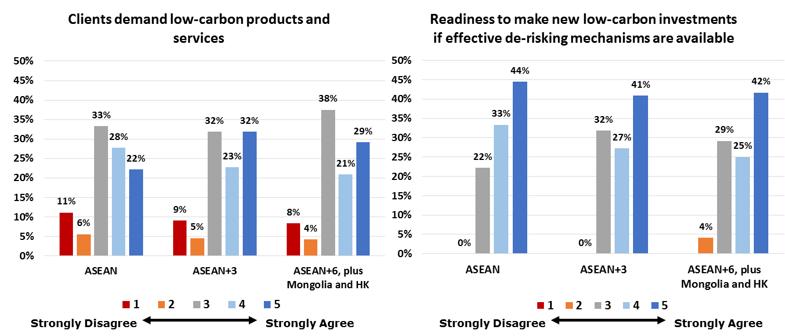
Perceptions of operational and financial risk prevent the further leveraging of private capital towards low-carbon projects despite the availability of the technology and financing. It is shown by an average of 61% of lenders across all regions strongly agreed that there is a difficulty on finding a source of financial capital for low-carbon energy investment due to the high-perceived risk. Meanwhile, there is a strong demand for low-carbon investment amongst the Borrowers, which is shown in the results are about 50% - 55% of borrowers. As well, there are more than 50% of all borrowers are ready and willing to make new low-carbon energy investments will emerge if effective de-risking mechanism are available (Figure 1).
Figure 1. Demand and readiness for investment

Policy, operational, and political risks that are derived from changing policies, shifting politics, and subsidized and volatile energy markets hinder the institutions supporting low-carbon technology. These perceived risks decrease the confidence of Borrowers and Lenders seeking financing opportunities. In order to mitigate these risks, government institutions and policymakers have to utilize de-risking financing and support mechanisms. However, the second key finding of the survey shows that these approaches are weak, difficult to access, or unavailable.

Conclusions
The results obtained from the analysis of country level and regional data mostly complement and confirm the findings from aggregate data analysis. Econometric results revela that FDI flows to rise in response increase in the growth performance. Opportunities to raise capital from the public sector to finance the low-carbon transition are limited, which means that private and commercially sourced financing must be included in the low-carbon energy project development. Private investors make investment decisions based on the risk return prospects. Several bankable projects in developing and emerging economies of ASEAN and East Asia are not being implemented due to the lack of financial resources at an affordable cost. To this end, it is critical that national and regional institutions take actions to create policy solutions that leverage a greater degree of low-carbon energy investment. Before implementing far-reaching regional solutions, policymakers must address the political, policy, financial, technical, and operational risks that accompany low-carbon technology investments. The perception of market risks, the inability to mitigate these risks, and the lack of communication and coordination amongst market participants have been the key barriers to optimizing the low-carbon investment environment.

