Overview
Not All Energy Agents Maximize Profits:
Modelling Complexity of Investment in Oil & Gas Projects
John W. Ballantine, Jr. Senior Lecturer, Brandeies International Business School. johnbal@Brandeis.edu (978 371-2652)
Mohammed AlMehdar, Ph.D Candidate, Brandeis International Business School. mmehdar@brandeis.edu (857 400-4006)

mmehdar@brandeis.edu

Researchers from the Brandeis International Business School, in collaboration with King Abdullah Petroleum Studies and Research Center (KAPSARC) are building an agent-based simulation model that encompasses the scenario building efforts of Shell, et. al. on energy and climate models (Shell, BP, IEA, EIA, IPCC). This research contributes to the literature on the complexity of economic systems, showing how heterogeneity, path dependency, feedback loops, and learning by agents can dramatically alter price expectations and outcomes – investment and production -- predicted by traditional (equilibrium) economic or VAR models (e.g., how NOC or IOC agents react to price changes/surprises, shale production, and climate change goals / rules). Analyzing and parsing the investment and production decisions of different producers gives us the tools to model the dynamics of energy markets. We look at agents’ endogenous investment behavior to gain a better understanding of investment cycles and to model the transition from higher cost fields (regions) to a more sustainable future.
The underlying premise of our approach is that an agent-based model that uses a flexible structure can simulate market interactions and more particularly explain the investment and production cycles. In other words, energy producers have different investment / profit maximizing functions and the heterogeneity of investment matters. The investment, production, and cash flow actions of National Oil Companies, Independent Oil Companies and Shale producers, operating in fields with different costs affects energy supply and, of course, prices. Our agent based, fuzzy logic model lets us to run “what if” simulations by changing common language assumptions (e.g. behavior rule: invest more in shale if prices are high/over $60 a barrel; expand low cost oil & gas fields if expected demand / price peaks in five years). By using field level data to estimate agent investment functions derived from heterogeneous profit expectations we explain the differences of oil production of individual agents and resulting market dynamics.
We use an agent model to analyze how shale oil and traditional producers enter / exit the oil market (invest) in response to price expectations, volatility, and cycles. In this paper, we are parsing out the investment behavior and actions of different production agents investing in different fields / projects throughout the world. It is our premise that a simple profit maximizing function does not explain the varying investment decisions of energy agents.

Methods -- Competitive market assumptions: Investment, Production and NPV?
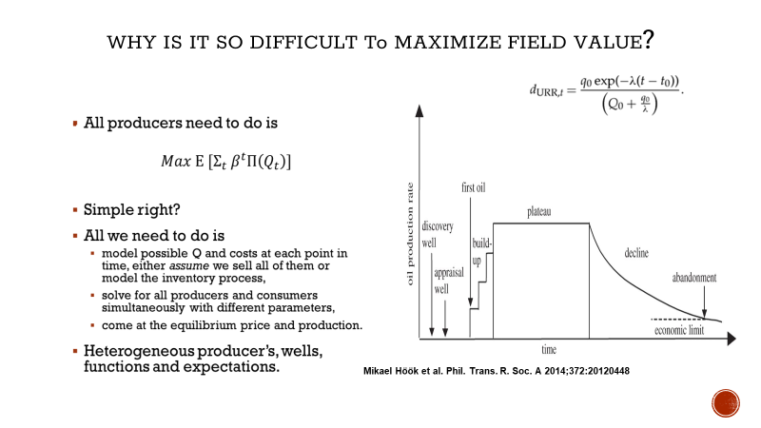
Not all oil and gas fields have the same characteristics and not all operators have the same profit maximizing functions (expectations) and financial resources. However, many analysts use traditional competitive market assumptions to model investment and production decisions of independent operators. We examine these assumptions using field level data to test simple profit maximizing functions and then derive more heterogeneous investment functions for different energy agents operating over different time horizons, with variable cost functions, and financial capacity.
1. Investment, production, and breakeven costs are divergent, cyclical, and volatile across geography and fields (see figure below). The question then is how to estimate and derive simple profit maximize functions for different regions and operators across to the world. We test a series of approaches with variable time / price horizons to test how well profit maximization explains investment cycles, from which we derive more realistic agent investment functions.
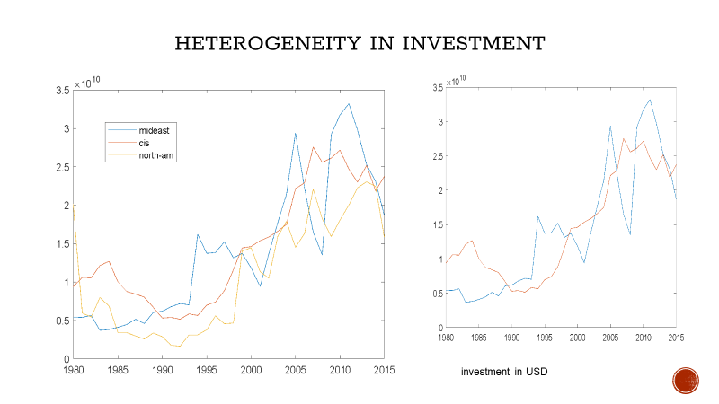
As seen in the Figure above we show the heterogeneity of investment (and production) in different regions of the world is based on location and resource characteristics (North-America/Shale, Middle-East/On-Shore, etc.). Regions and fields are our first set of agents, and then, we will look at primary operators to understand investment behavior of a cross section of fields. The parameters describing agent’s investment behavior are taken from historical field data from 1970 to 2016. We realize that there are different historical periods (OPEC through 1970s, Iran-Iraq war, followed by over supply and large deep-water fields 1990s, and post 2001) that help explain different investment / production cycles and expectations (Kilian). Finally, we test our agent behavioral statements using specification of the investment heterogeneity and production across regions and operators (NOC, IOC, CIS, Shale, Deepwater, etc.)

2. There is a significant uncertainty in our energy system, whether we look at uncertainty in the data we use
to estimate models, uncertainty that the agents face when form price expectations and make investment, uncertainty in future demand, or uncertainty regarding individual agents’ reaction to climate agreement goals. Our fuzzy logic approach allows us to deal with a wide range of uncertainty by describing each agent using the following rule format:
IF price IS high THEN my-investment IS high
IF cash-flow IS low THEN my-investment IS low
IF expected-demand IS high THEN my-investment IS high
The common language framework allows us to describe the rules easily (after rejecting simple profit maximization functions), and then use fuzzy logic behavioral statements to illustrate what the variables mean (e.g. high price could be anything above 120% of producers’ cost, which will vary by producer). Using this granularity, we are then able to calibrate investment actions by agents separately. The module structure lets us put variable weights for each agent; e.g. one producer can interpret price to be (0.7 high) and expected-demand to be moderate (0.4 high), and then given these expectations weight investment to be sort of high (0.6 high). Others will have different weights and actions. This approach allows for more human / interactive responses to varying perceptions and risk assessments of each agent. Given the large number of fields and agents, we only model the most significant and consequential agents.

Results
Our preliminary results show that the differing characteristics of regional-fields (agents) matter – endogenous decisions regarding investment, lead-time, and probability of success affect producer reactions to and expectations of prices and supply-demand balances. Our model helps explain the boom and bust investment cycles due to field costs and price expectations – the endogeneity of investment decisions. In other words, the actions of agents across regions and the heterogeneity of investment / production decisions generate endogenous market cycles, and surprises.

The purpose of this research is first to unpack the complexity in the investment behavior of energy suppliers (mainly through feedbacks and heterogeneity of agents, such as shale and NOCs), and to show how investment behavioral has changed over time (not a fixed NPV function). Second, to see how shifting investment behavior has had an impact on traditional modelling approaches and how agent/fuzzy logic framework helps us understand market cycle dynamics (in contrast to general equilibrium models, VAR shock / surprise analysis, or more macro models).

Regarding our first objective, we show that investment behavior / cycles is heterogenous across regions. It appears that these endogenous cycles are largely a function of producer heterogeneity, lead-times, decline rates, costs, price expectations, investment and cash flow. We plan to more carefully parse regional and operator investment behavior.

For the second objective, we believe that the rapid increase (decrease) in shale production does result in a structural shift in supply adjustments, investment, and price volatility. However, the changing oil market dynamics involve the interaction of all producer/agents with different investment actions and production levels. Competitive more profit maximizing shale oil producers operate differently than NOCs and large low-cost energy producers who are attempting to diversify their energy economies. The model shows how agent actions / interactions and learning matter a great deal.

Conclusions
Understanding the post-shale oil market requires that we include the uniqueness of the shale-oil investment / production process and specify the difference between shale-agents and traditional energy players. If cycles are endogenously generated due to production constraints (lags and declines), then the shale boom and OPEC production quotas is not simply a result of technology, or supply shocks. We show how differentiating investment behaviour of significant agents is critical to deciphering the shape of our investment, production and price cycles.
A multi-agent approach gives us the flexibility to model the heterogeneity of energy producers and to describe the differences in energy agent behaviours, production profiles, and company / country objectives. Such heterogeneity requires an increase in the modelling specification (in terms of data needs and agent behaviour). The fuzzy logic formulation allows us to deal with the challenge, as large numbers of behaviors can swiftly be described, modified and evaluated by experts using linguistic rules as opposed to equations.

Our modelling exercise shows the importance of dealing with complexity in our energy systems. For oil supply, we look at both the introduction of shale and the reactions / changes in traditional producer investment behavior. Unpacking the heterogeneity of investment and agent behavior lets us see how endogenous actions affect market volatility and cycles. Shale agent behaviour has disrupted energy markets and is changing longer term production decisions and oil prices.

This is a multi-party research initiative to design, implement, and test the flexible/modular modelling tool for the energy market, energy participants, and policy makers. The model shows how the actions of agents, particularly shale and NOCs are critical, and that their investment decisions probably change the trajectory of energy markets.

References
Baumeister, C., Kilian, L., “Forty Years of Oil Price Fluctuations: Why the Price of Oil May Still Surprise Us,” Journal of Economic Perspectives, Winter 2016 (vol. 30, Number 1)
Bornstein, G., Krusell, P., & Rebelo, S. (2017). Lags, costs, and shocks: An equilibrium model of the oil industry (No. w23423). National Bureau of Economic Research.
Economou, A., Agnolucci, P., Fattouh, B. and De Lipsis, V. (2017), ‘A Structural Model of the World Oil Market: The Role of Investment Dynamics and Capacity Constraints in Explaining the Evolution of Real Price of Oil’, OIES Energy Insight 23, Oxford: Oxford Institute for Energy Studies.
Kilian, L. (2009). Not all oil price shocks are alike: Disentangling demand and supply shocks in the crude oil market. American Economic Review, 99(3), 1053-69.
Kleinberg, R. L., Paltsev, S., Ebinger, C. K., Hobbs, D., & Boersma, T. (2016). Tight oil development economics: benchmarks, breakeven points, and inelasticities. MIT Center for Energy and Environmental Research.
Hamilton, James D. “Historical Oil Shocks,” (2013) In Routledge Handbook of Major Events in Economic History
Hamilton, James D. “Oil Prices, Exhaustible Resources, and Economic Growth.” (2013). In handbook on Energy and Climate Change edited by Roger Fouquet, Edward Elgar
McGlade, C., Bradshaw, M., Anandarajah, G., Watson, J. and Ekins, P. (2014) A Bridge to a Low-Carbon Future? Modelling the Long-Term Global Potential of Natural Gas - Research Report (UKERC: London).
Paltsev, S., 2017, "Energy Scenarios: The Value and Limits of Scenario Analysis," WIRE Wiley Interdisciplinary Reviews: Energy and Environment, 6, e242. (also, MIT working paper CEEPR 2016-007)

Appendix and additional information
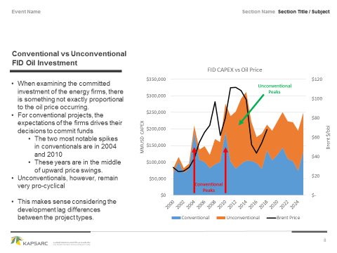
IHS, Lindemer
