ANALYSIS OF ENERGY INTENSITY OF BASIC MATERIALS INDUSTRY IN JAPAN

Junichiro Oda, RITE, Phone: +81 774 75 2304, E-mail: jun-oda@rite.or.jp
Keigo Akimoto, RITE, Phone: +81 774 75 2304, E-mail: aki@rite.or.jp

Overview
Although climate change is a long-term problem, it is important to understand the current situation in order to respond to the question of what policy measures should be taken now from a shorter-term perspective. It is important to understand how and why the energy consumption has changed in energy-intensive industries.
Based on the above problem awareness, this paper focuses on energy intensity (GJ/t) of basic materials industry in Japan. The subjects of analysis are iron and steel, non-ferrous metal, cement, and glass sectors. The analysis period is mainly from 2000 to 2016. As shown in Figure 1, the energy consumption of the Japanese industrial sector is on a downward trend. The aim of this paper is to clarify whether the trend is mainly a production factor or an energy intensity factor.
Figure 1. Industrial sector energy consumption in Japan

Methods
In terms of production data, we referred to Japanese government statistics, e.g., METI (2017c), and other domestic statistics e.g., Cement Press (2017), and JISF (2017). In terms of energy consumption data, we referred to METI (2017a, b). Energy intensity (GJ/t) is calculated by dividing energy consumption by production volume. We also estimated yearly capacity factor and its impact on energy intensity in iron and steel, and cement sectors based on Oda et al. (2016).

Results (selected)
Figure 2 shows the results of iron and steel sector in Japan. The estimates (red line) partially explain the primary energy intensity trajectory (black line) from 2000 to 2017. The estimates consist of three factors: hot metal ratio (x₁), steel product mix (x₂), and capacity factor (x₃). Figure 2 reveals that capacity factor had a large impact on energy intensity in the short term, for example, the change from 2008 to 2009, which makes it more difficult to detect long-term trends in energy intensity.
Figure 3 indicates the results of cement sector in Japan. The estimates partially explain the primary energy intensity trajectory from 2000 to 2017. The estimates consist of three factors: clinker to cement ratio (y₁), waste and by-products (y₂), and capacity factor (y₃). Expanding the use of (wet) waste and by-products significantly affects the energy intensity, and the energy intensity of cement sector was deteriorating after 2005.
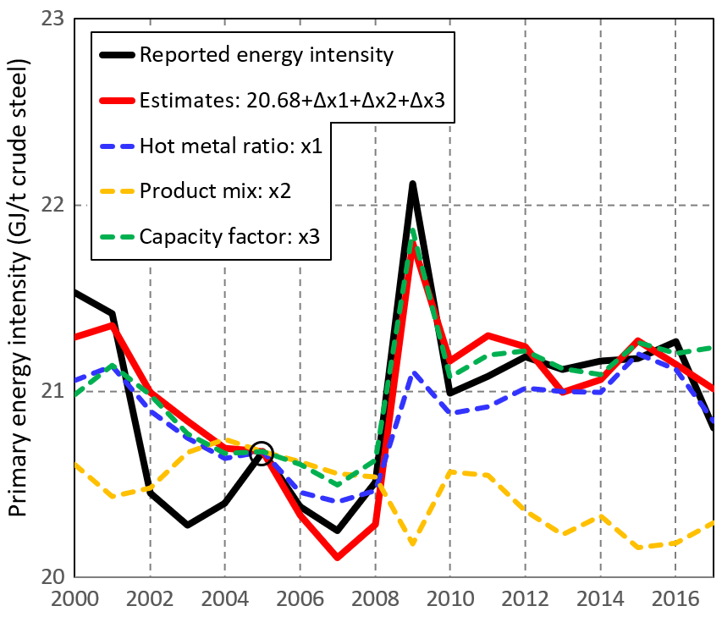  Figure 2. Results of energy intensity of  iron and steel sector in Japan (base year: 2005) | 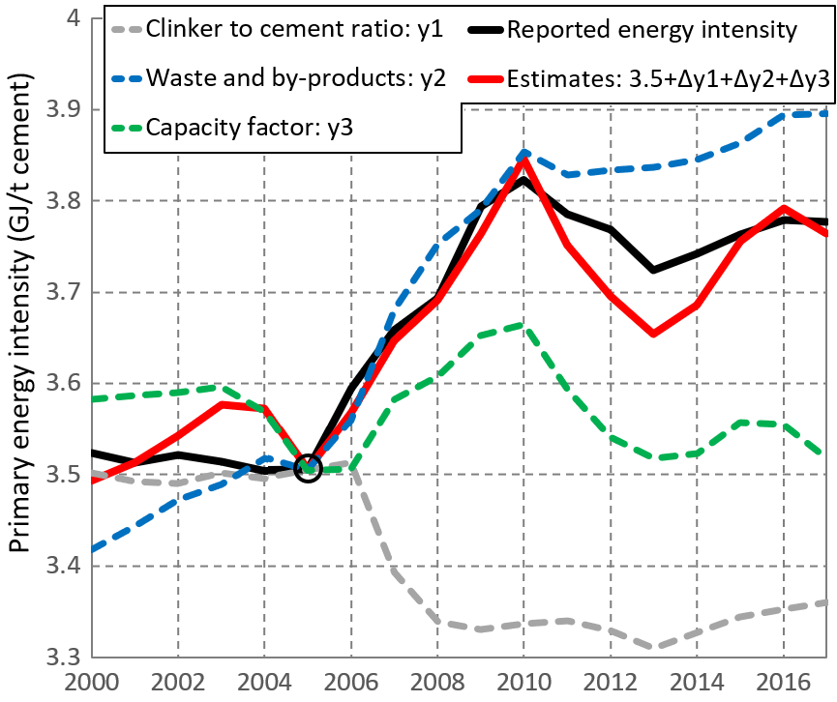  Figure 3. Results of energy intensity of  cement sector in Japan (base year: 2005)

Summary
Based on various statistics, this paper empirically investigated energy intensity of iron and steel, non-ferrous metal, cement, and glass sectors in Japan, and quantitatively and qualitatively examined the fluctuation factors of energy consumption. Table 1 summarizes the production volume, energy intensity, and energy consumption for the three sectors. As shown in Figure 1, energy consumption tended to decline, and the decrease in production amount in both three sectors was observed. While the energy intensity of the steel sector was improving, the energy intensity of non-ferrous metals and cement sectors was deteriorating. In the cement sector, expanding the use of (wet) waste and by-products affected the trend in energy intensity. Capacity factor also had a large impact on energy intensity.
The results obtained above would be valuable basic information for discussion of further energy intensity improvement and CO₂ emissions reduction in these sectors.
Table 1. Summary of iron and steel, non-ferrous metal, and cement sectors in Japan
 | Production volume | Energy intensity | Energy consumption
Iron and steel (from 2000 to 2016) | -1.6% | -1.2% | -2.8%
Non-ferrous metal (from 2010 to 2016) | -14% | +5% | -9%
Cement (from 2000 to 2016) | -29.2% | +7.2% | -24.1%
Note) In non-ferrous metal sector, production volume and energy intensity mean a weighted average of the final energy consumption of each product (zinc, electrolytic lead, electrolytic copper, ferronickel, aluminum ground metal, and aluminum rolled products).

References
Cement Press, 2017. Yearbook of cement industry 2017. (in Japanese)
Junichiro Oda, Keigo Akimoto, Takashi Homma, 2016. Carbon intensity and its determinants in Japanese steel industry, The 5th IAEE Asian Conference, Perth, Australia, Feb 14-17, 2016.
Ministry of Economy, Trade and Industry (METI), 2017a. General Energy Statistics 2017. (in Japanese)
Ministry of Economy, Trade and Industry (METI), 2017b. Monthly Report of the Current Survey of Energy Consumption: Total-C.Y.2017. (in Japanese)
Ministry of Economy, Trade and Industry (METI), 2017c. Yearbook of current production statistics 2017. (in Japanese)
Japan Iron and Steel Federation (JISF), 2017. Handbook for iron and steel statistics. (in Japanese)

