Assessment of the demand response aplication in europe and its complementary/competitive character with storage technologies

Juan Jose CORTEZ, GAEL, CNRS- Univ. Grenoble Alpes-INRA, 38400 Saint Martin d’Hères, France,
Adrien BIDAUD, LPSC, Univ. Grenoble Alpes, CNRS, adrien.bidaud@grenoble-inp.fr, 38000 Grenoble, France
Silvana MIMA, GAEL, CNRS, Univ. Grenoble Alpes-INRA, 38400 Saint Martin d’Hères, France
Gabin MANTULET, LPSC, Univ. Grenoble Alpes, CNRS, 38000 Grenoble, France
Elena STOLYAROVA, LPSC, Univ. Grenoble Alpes, CNRS, 38000 Grenoble, France

Overview

Renewable energy sources are expected to take a very large share of electricity production in 2 degrees scenarios. The main objective of the study is to analyze the use of the demand response (DR) in high variable renewable depending electric power systems and explore the potential advantages of using DR to compensate intermittency. We also considered the interactions of DR with the entire power system, including the other flexibility options (storage, electric grid, and dispastchable power plants) using European Unit Commitment And Dispatch (EUCAD) model. In the supply and demand balance modelling, DR is similar to electricity storage: they both displace an electric load between two time-periods, although their technical operating constraints differ which makes their economic models and behaviours slightly different.

We perform studies with very different renewable shares which are expected to be representative of different time horizons, today, in 2030 and 2060, years. We found that the need for implicit DR grows up to 20 % of the peak load but might have a value after which its use is saturated. Surprisingly, the competition with storage capacities appear to be very limited. Regarding to explicit DR, the level of usage is more sensible to the price when the high VRE claims for more flexibility.

Methods
The methodology of the EUCAD development and insights from the model improvements is described. EUCAD minimizes the marginal cost in daily basis. This allows us to perform simulations in different scenarios built to show up different aspects of this technologies. Some scenarios and sensitivity tests are analysed to answer the following research questions:
How DR can compensate the VRE power intermittency generation? What are the economics of DR? What will be the future role of DR in EU power systems? How does demand response affect the use of other flexibility options in particular storage? For our simulation, we need information about features as variable cost, ramping cost, maximum power, daily and week availability for each DR provider. DR is expected to only displace energy demand. Over the day, the energy consumed are always equal whatever the level of DR use. It is expected that DR will be often associated with the building’s heating, for which demand can be shifted by less than one our. So, we considers that every time that DR is called to produce (positive part) there is an increase in the consumtion (negative part) at the previous or next hour. Fig.1 shows the total energy produced by DR in tthese wo different “rebound effect” setups.

Results
Our results show that Storage and DR are used in different periods of the day. The Fig 2 shows the energy produced by Storage and Demand Response as a function of the Installed Power of DR capacities at different storage levels .
From Fig. 2 we can conclude that the total energy produced during a year is a linear function of the installed DR power, (in the proposed range which corresponds to a maximum power between 1 and 8 % of the peak demand) with installed DR power and is independent of Storage installed power. Conversally, use of Energy storage decreases a little bit with installed power of DR, but almost not increase with insllaled power of Storage, demonstrating a saturation of Storage before 10GW.
It is remarkable that the leading coefficient of both lines are differents, showing a very partial substitution and competition between DR and Storage. When we increase the DRs capacities the storage production decreases but when increasing storage for a fixed DR level, the production is the same.

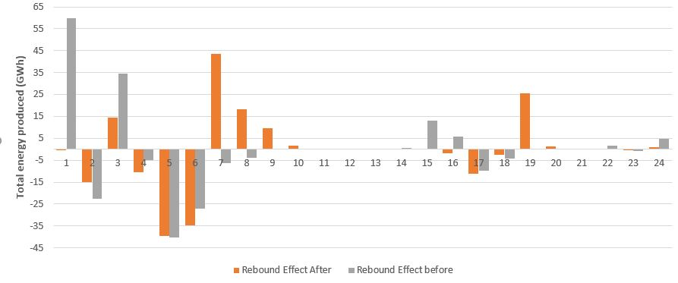
Figure 1. Total energy produced during the summer in France for 2030 in a scenario with an installed power of DR equal to 4GW (around 4% of the maximum peak demand).

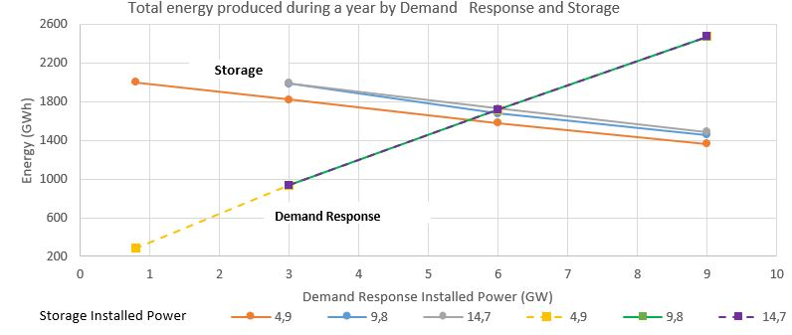
Figure 2. Energy produced by Storage and Demand Response as a function of the Installed Power of DR capacities at different storage levels.

Figure 3 shows the change in shifted demand if cost of DR is changed from 0 to 0.001 and 0.01 k$/kWh for each European country in 2030. The behaviour of DR seems to be very different betweend countries, probably as a function of availability of other flexibility options : hydro capacities and other dispactchable productions. The comparison of the same figure for 2060 when much higher contributions of variable renewable and a reduction in dispacthcable capacities are expected shows that DR demand may become more robust to cost increase and to countries’ specificities.

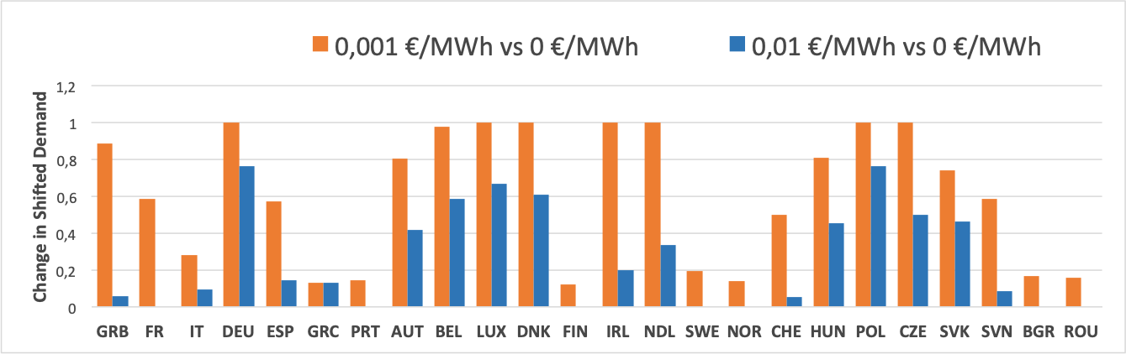
Figure 3 Change in Shifted Demand as a function of cost in 2030

Conclusions
the need for DR is shown to increase with higher penetration of renewable and reduction of backup dispatch-able capacities between 2030 and 2060. We have seen that this increase may become very robust to pretty high cost of DR. Surprisingly, the competition with Pumped Hydro Storage is found to be limited. Further research are needed to understand competition with other flexibility options.

